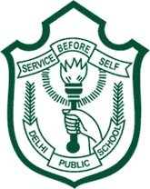 | DELHI PUBLIC SCHOOL, SRINAGAR
 | Worksheet-01
 | Sense organs
 | Subject: Ev.Sc. | Class: I

Q1. Tick the correct answer:
1. We have _________ sense organs. ( five / seven )
2. I see with my __________ . ( ears / eyes )
3. My __________ help me hear. ( skin / ears )
4. I can ___________ ice cream with my tongue.( see / taste )
5. I can ___________ with my nose. ( smell / hear )
6. My skin helps me _________ things. ( see / feel )
7. I listen to music with my _________ . ( nose / ears )
8. I watch cartoons with my ________ . (eyes / hand )
Q2. Rearrange the following words to get the name of a body part, one is done for you:
1. haed _____________________
2. lge _____________________
3. rae _____________________
4. ncke _____________________
5. nails _____________________
6. ewlbo _____________________
7. neke _____________________
8. finreg _____________________
9. eson _____________________ 10. Hnad _____________________

Q2. Solve the riddles:
- I am very weak plant. I need support to grow. I need support.
___L___ ___B___R
- I am hard outside and soft inside. I give you oil..
C___C___N___T
Q3. Give two examples of each that we eat:
- Roots 1. _________________ 2. _________________
- Stem 1. _________________ 2. _________________
- Leaves 1. _________________ 2. _________________
- Seeds 1. _________________ 2. _________________

Q3. Match the following:
- Shrubs have One seed
- Creepers grow along root
- Muskmelon has hard stems
- Litchi has many seeds
- Radish is a the ground

Q4. Each finger has a name. Can you write it?
- ___________________________
- ___________________________
- ___________________________
- ___________________________
- ___________________________

Q1. Complete this family tree:
 | DELHI PUBLIC SCHOOL, SRINAGAR
 | ASSIGNMENT- 02/T1
 | (Topic: Meet my family & my home)
 | Subject: Ev.Sc. | Class: I | Grade:
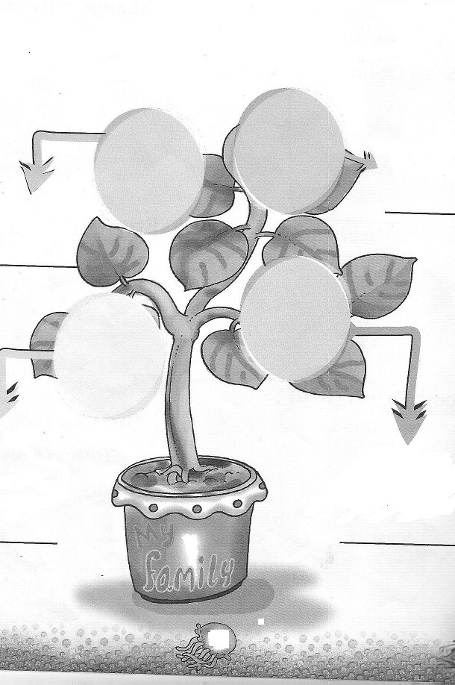

Q2. Do you help your family? Write yes or no.
- I water the plants. ___________
- I cook the food. ___________
- I keep my room clean. ___________
- I pack my bag on my own. ___________
- I wash my clothes. ___________
Q3. Think and fill in the blanks:
- We live in a __________________.
- A house provides us ___________________.
- The house we live in is our ________________.
- We should keep our house ________________.
- A house has ________________ rooms.
Q4. Answer the following questions:
- Where do you take a bath?
_______________________________________________
- Where does your mother cook food?
_______________________________________________
- Where do you sit with your guests?
_______________________________________________
- Where do you sleep?
_______________________________________________

Q1. Paste pictures showing different uses of water.
 | DELHI PUBLIC SCHOOL, SRINAGAR
 | ASSIGNMENT- 03/T1
 | (Topic: Food & water, Clothes)
 | Subject: Ev.Sc. | Class: I | Grade:

__________________________________ ______________________________

_
_______________________________ _____________________________

Q2. Complete the crossword with the help of clues:
- Drink it twice daily.
- Drink 8 – 10 glasses daily.
- Eat one daily to keep the doctor away.
- I eat it for breakfast.

Q3. Tick the correct answer:
- Clothes harm / protect our body.
- We wear same / different types of clothes.
- During summer I like to wear cotton / woollen clothes.
- I wear a uniform / frock to school.
- We should wear dirty / clean clothes.
Q4. Draw the missing part and make the picture.

Q5. Collect the pictures of the different states of our country and paste them in the space provided below. Also write the names of the states below the pictures.

