DELHI PUBLIC SCHOOL, SRINAGAR
REVISION WORKSHEET
SUBJECT: MATHEMATICS
CLASS: V

Q1. Using fraction conversion, match the arrows with the correct head of Ravan to destroy him.
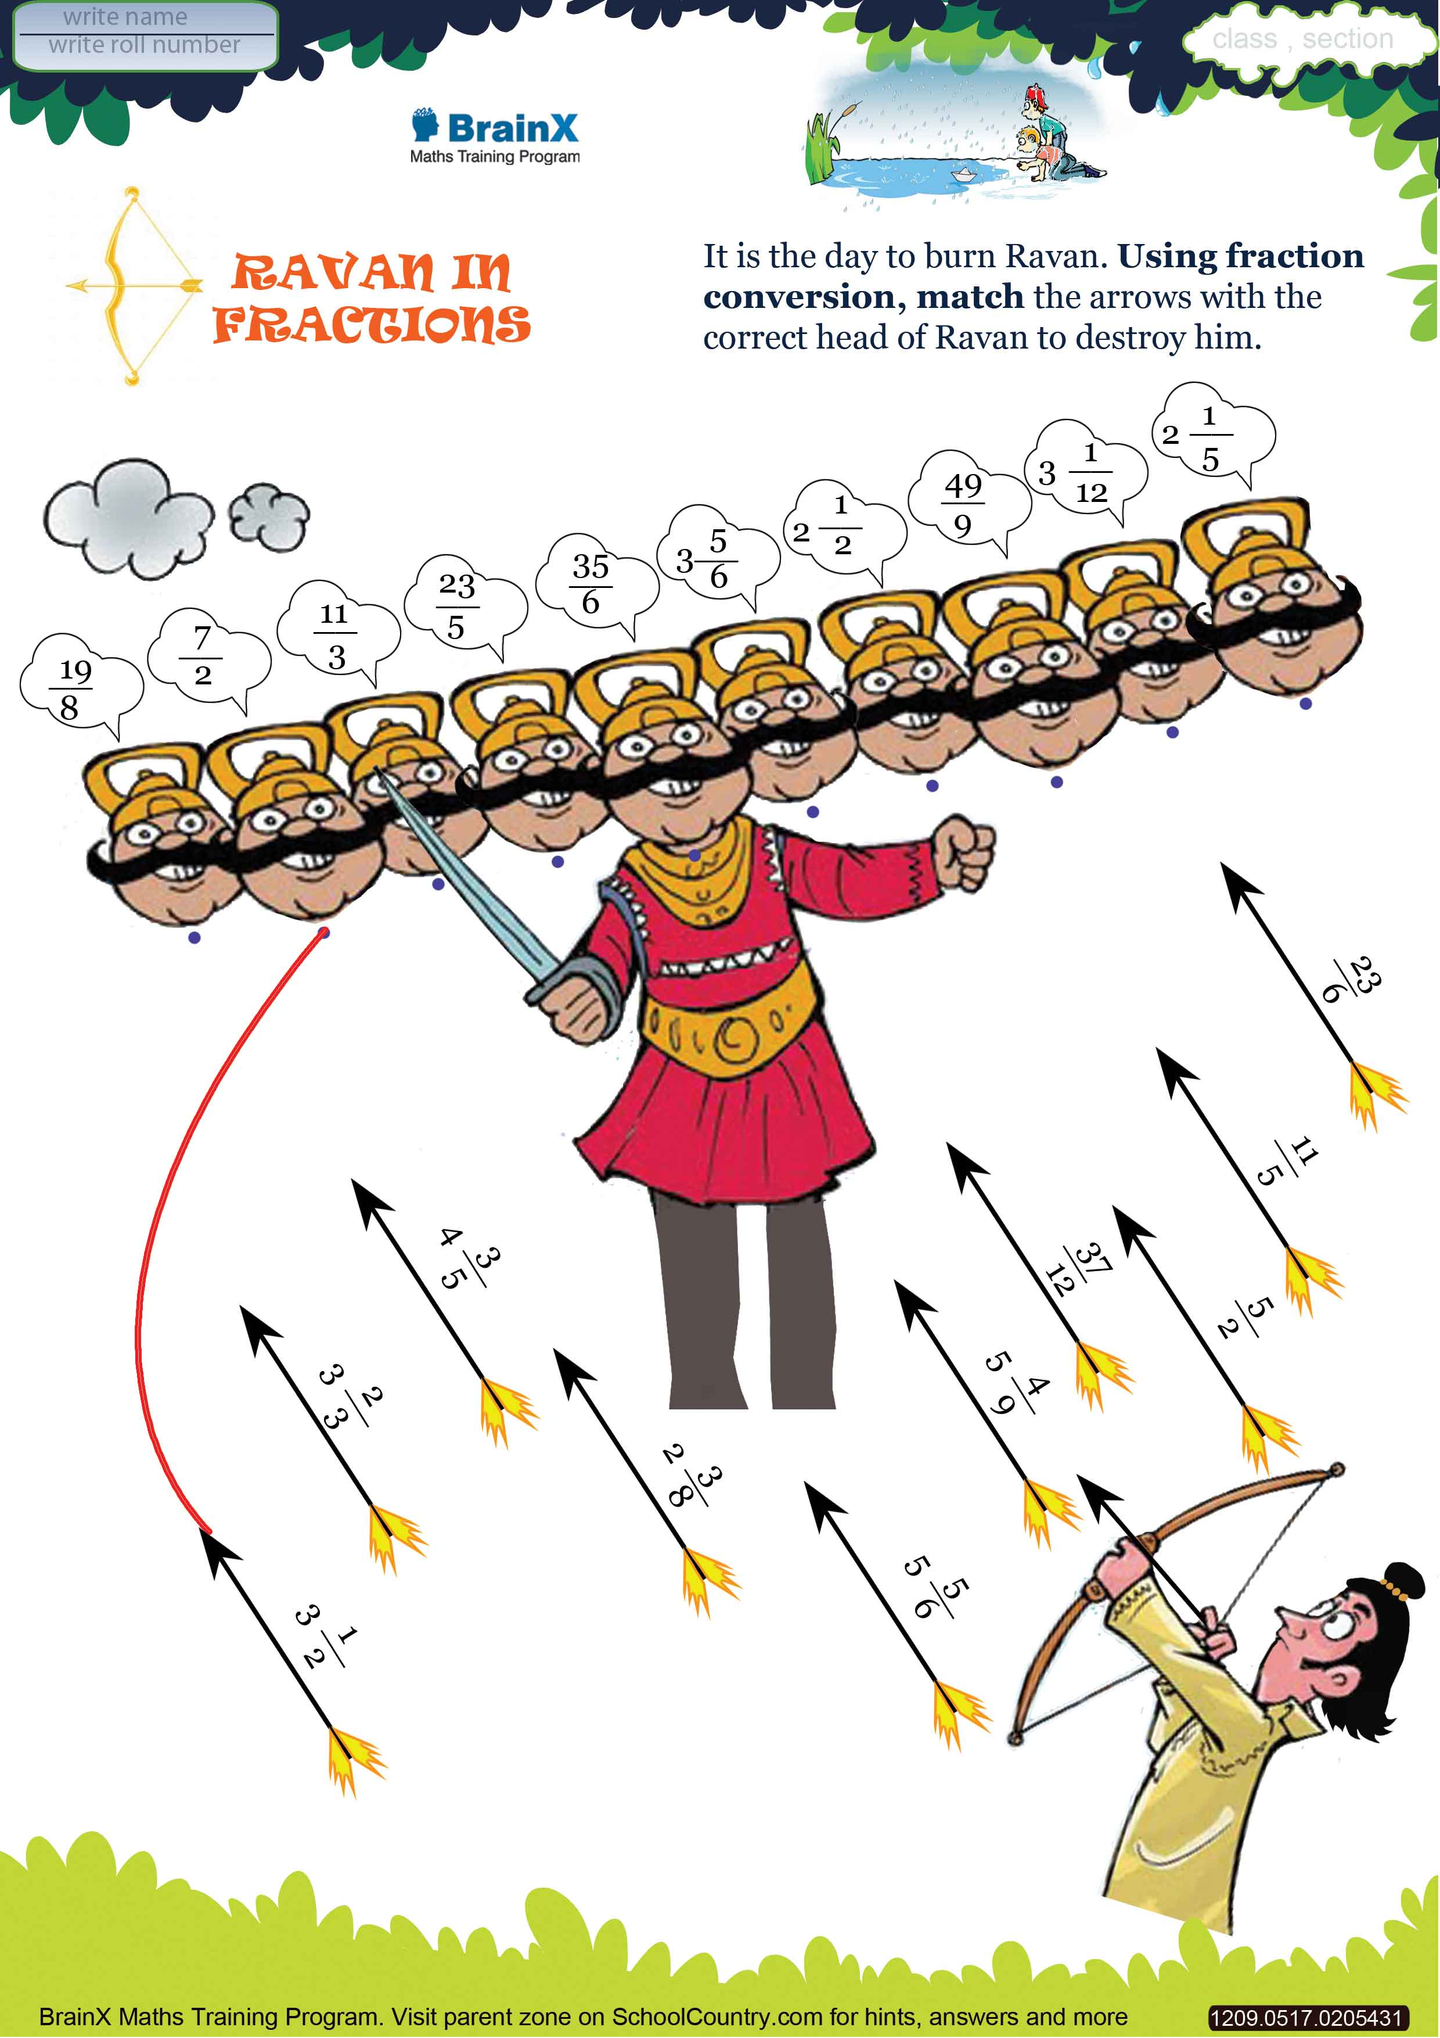

Q2. Compare the following.
