|  |  |
| --- | --- |
| C:\Users\Dps\Desktop\Important\school emblem1.jpg  **DELHI PUBLIC SCHOOL**  **SUMMER ASSIGNMENT** | |
| **Name:** | **Class :** |
| **Subject: English** | **Grade:** |

Q1: Look at the pictures and write the first letter of the word. ____________

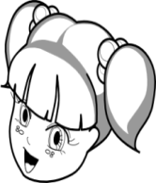 ____________

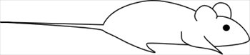 ____________

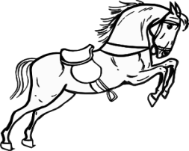 ____________

[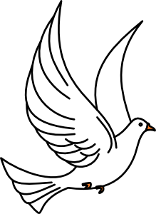](javascript:edit(29963)) _____________

Q2: Fill in the missing letters to make three letter word.

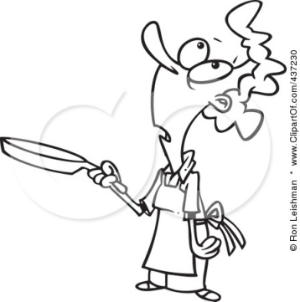P______n 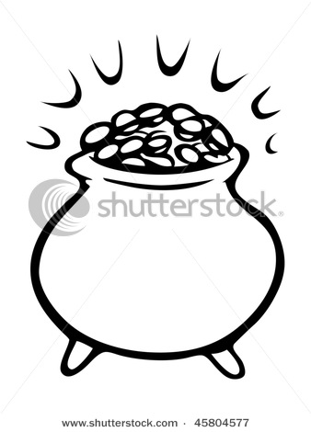p_____t

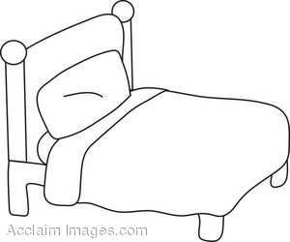 ____ e d 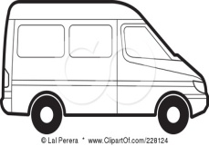 _____a n

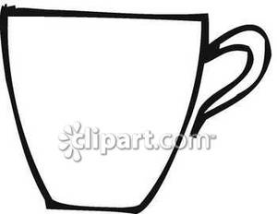c u_____ 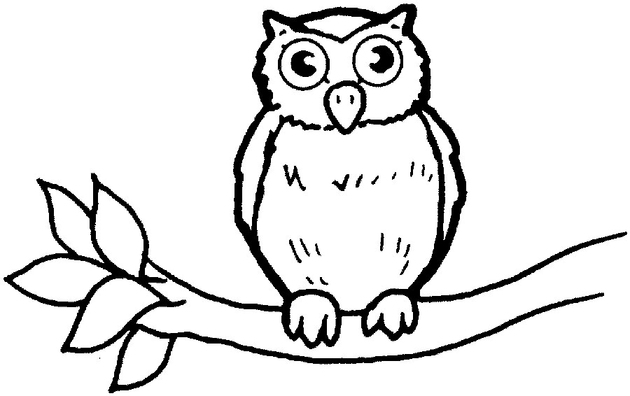 o w _____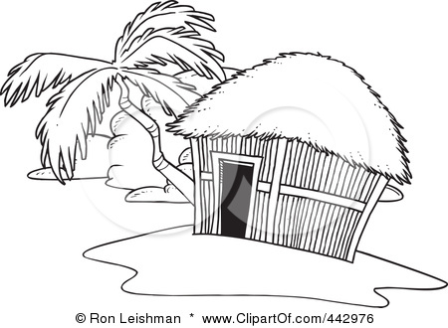 h____t 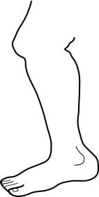 l_____g 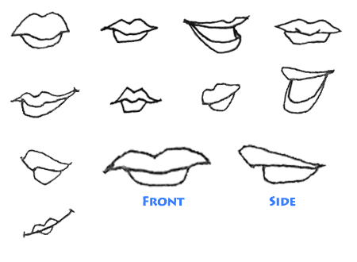 l____p [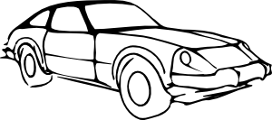](javascript:edit(16996)) c___r

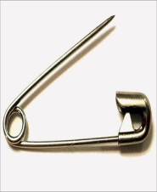 p___n

Q3:Match the word to the picture.

Axe 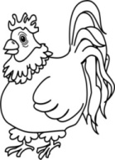

Hen [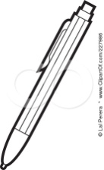](http://images.clipartof.com/small/227986-Royalty-Free-RF-Clipart-Illustration-Of-A-Coloring-Page-Outline-Of-A-Ballpoint-Pen.jpg)

Rat [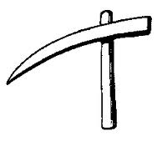](http://www.google.co.in/url?sa=i&source=images&cd=&cad=rja&docid=HgRMOFCCYkph9M&tbnid=fyrfXR6sU_XsLM:&ved=0CAgQjRwwAA&url=http://www.heraldsnet.org/saitou/parker/Jpglossa.htm&ei=wBhgUeG1EcTJrAfruIHoDQ&psig=AFQjCNH6jqtfGEXHs4IhuEsHYavcrXYFEQ&ust=1365338688322353)

Pen 

Tea  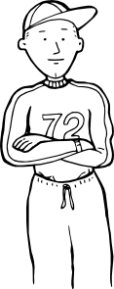



Boy

Q4:Match the following to form a word.

[](http://www.google.co.in/url?sa=i&source=images&cd=&cad=rja&docid=VYHIF875l07FIM&tbnid=O3uaIknOnpV3AM:&ved=0CAgQjRwwAA&url=http://thenshewrites.blogspot.com/2011_04_01_archive.html&ei=5pXrUcv7LYrqrAe_8IGABA&psig=AFQjCNFAeUBNc747h2a8Sd86mT9lxo0Z9Q&ust=1374480230841034) nap cil

[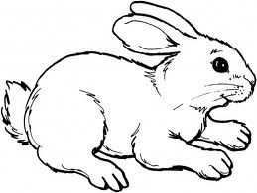](http://www.google.co.in/url?sa=i&source=images&cd=&cad=rja&docid=gHetwdwJwKUwGM&tbnid=kfZ3K2oq5llrrM:&ved=0CAgQjRwwAA&url=http://www.supercoloring.com/pages/category/mammals/rabbits/&ei=_5brUf7JH4qHrgek_YC4Dw&psig=AFQjCNF2SCA-3qYrkj9l_51Exq64ho7_Cw&ust=1374480511601607) rab key

[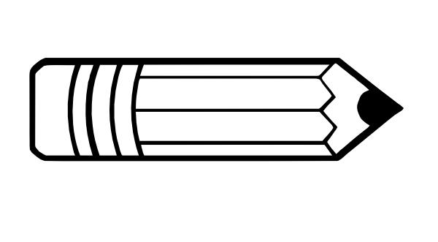](http://www.google.co.in/url?sa=i&source=images&cd=&cad=rja&docid=00XeC-pVByrhMM&tbnid=2Jf-H6uFGrGWvM:&ved=0CAgQjRwwAA&url=http://www.clker.com/clipart-pencil-outline-1.html&ei=X5frUYjlB8nrrQfa1YGgBA&psig=AFQjCNG_j1dB4321BekOe8zsdeXstiYVvw&ust=1374480607215496)pen bit [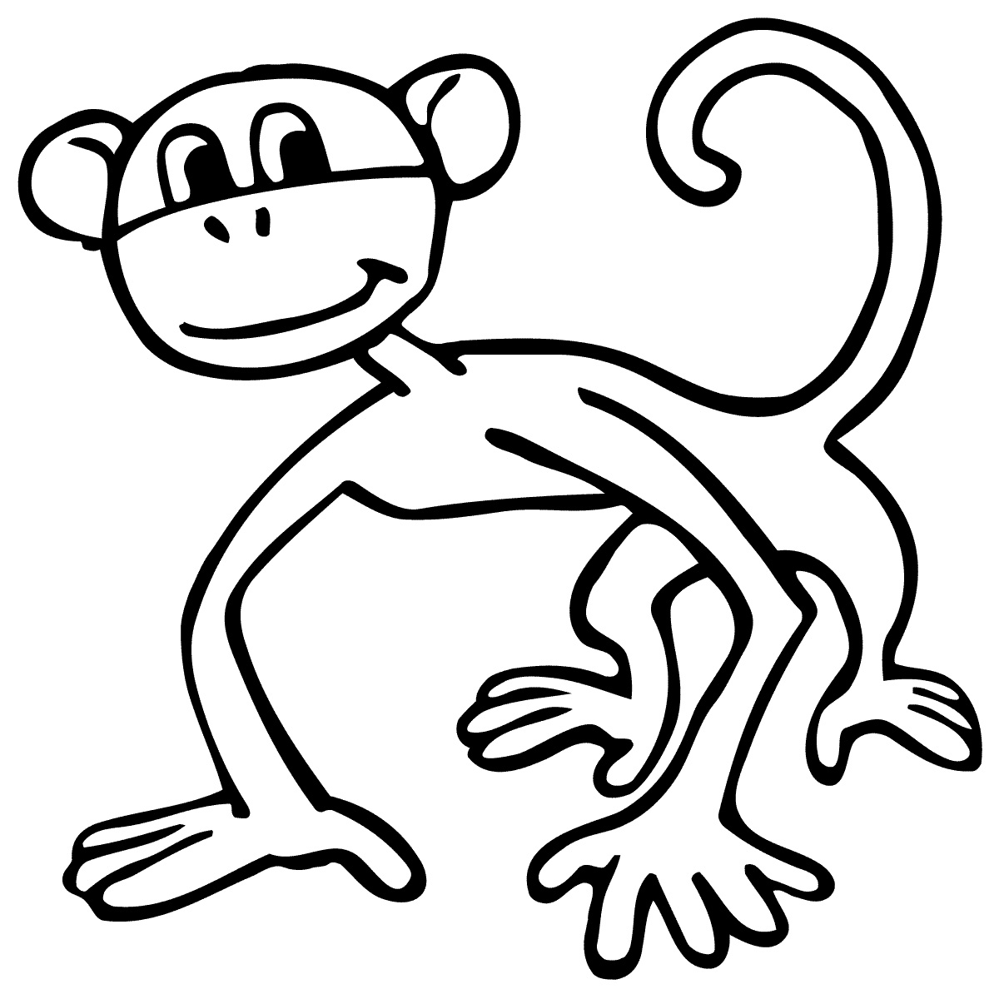](http://www.google.co.in/url?sa=i&source=images&cd=&cad=rja&docid=UzWsWZqb_POYBM&tbnid=ZpUl0PzBR435CM:&ved=0CAgQjRwwAA&url=http://coloriages.ws/?s=Th%C3%A9%C3%A2tre%20Cartoon%20Cartoon%20Network&ei=mRBsUfyUBo2rrAfDxoCACQ&psig=AFQjCNEgtwpljE2Jfn8oMUdh89DcjZDTKQ&ust=1366123033157905) mon kin

Q5: Circle the objects beginning with sound of the letter ‘e’

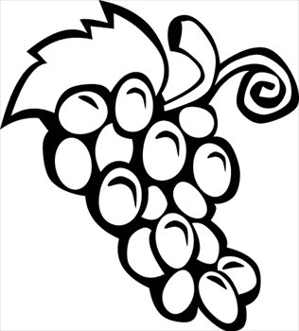 [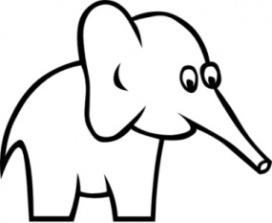](http://www.google.co.in/url?sa=i&source=images&cd=&cad=rja&docid=feZF2typvkRb0M&tbnid=71jppYQN_O5_HM:&ved=0CAgQjRwwAA&url=http://vector.us/browse/149764/cartoon_outline_elephant_clip_art&ei=o8BbUbzUCMrNrQemzoCwDA&psig=AFQjCNH3kCJBMP6pGNcV4oZhiOYN0y1GKA&ust=1365053987182894) 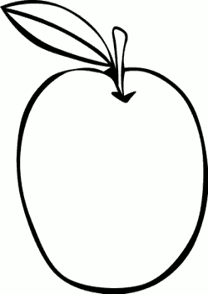 [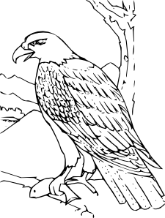](javascript:edit(14358)) [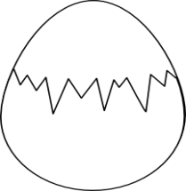](javascript:edit(16405)) 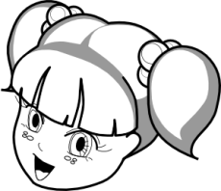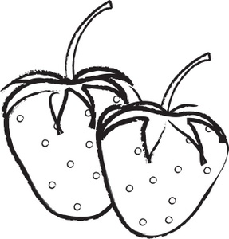 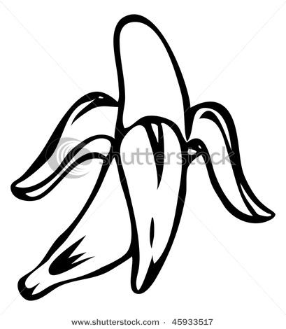

[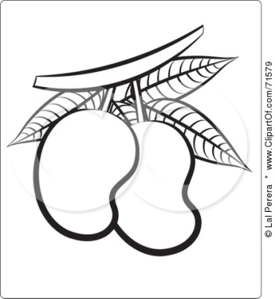](http://images.clipartof.com/small/71579-Black-And-White-Outline-Of-Mangoes-Poster-Art-Print.jpg)