DELHI PUBLIC SCHOOL,SRINAGAR



ASSIGNMENT FOR CLASS VI

Social Science (Geography)

MAP WORK

1. **On the outline political map of the India, mark and label the following states.**
2. Gujarat ii) Madhya Pradesh iii) Assam iv) Goa
3. Kerala vi) Chattisgarh vii) Nagaland viii) Bihar

xi) Jharkhand x) Himachal Pradesh

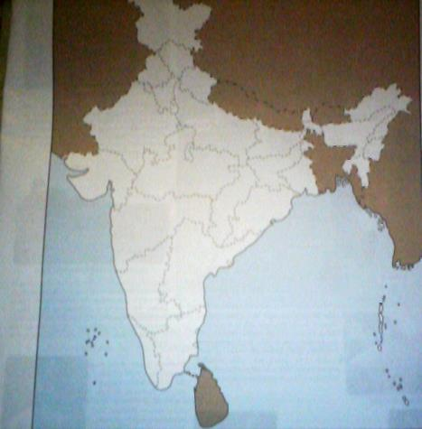

1. **On the outline physical map of the India, mark and label the following physical divisions.**
2. Northern Mountains ii) Northern Plains

iii) Great Indian Desert iv) Great Peninsular Plateau

v) Coastal Plains and Islands

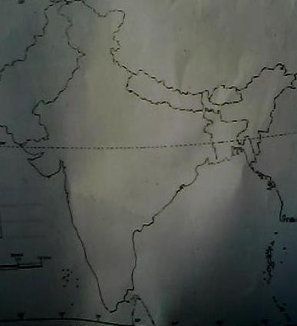

**PROJECT WORK:**

**Choose a state and write about its festival, people and their occupation. Collect pictures. What do you like most about the state?**