DELHI PUBLIC SCHOOL, SRINAGAR
Worksheet
ENGLISH
CLASS III / SEC. ___________ NAME__________________
Prepositions
A preposition is a word that shows the relationship between a noun or pronoun used with it and some other word in the sentence. It is used to show position, direction or time.
Remember
- A preposition usually comes before a noun or pronoun.
For example: The apples are kept on the table.
Take a look at these sentences.
- Put the box on the table.
( on shows the relationship between two nouns box and table )
- The king rules over a vast kingdom.
( over shows relation between a verb and a noun rules and kingdom )
These examples show that a preposition is a word that is placed before a noun or a pronoun to show the relation that the noun or the pronoun has with some other word in the sentence.
Preposition plays a vital role in speaking and writing English correctly. They are usually very small words. Yet, they are very important as they establish a relationship between the different parts of a sentence. Let’s take a look on pictorial formation.
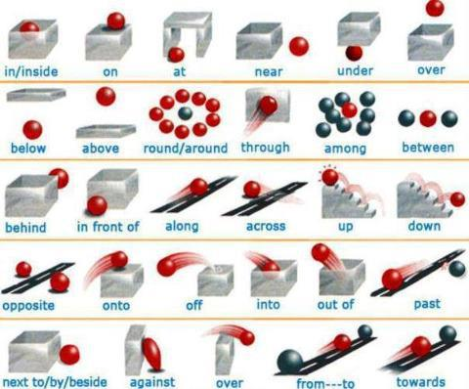

. Usage of prepositions
In: Implies inside within the shape or area of. It is also used with a specific time, period, month, season, and year.
For Example: We live in India.
In winter the weather is cold.
On : Means upon the surface.
For Example: The ball is on the box.
It is also used with days and dates.
The annual function is on Sunday.
At: It refers to fixed point or time.
Near : Very close
Beside: Shows a position next to.
Besides: Means in addition to.
By: Determines the time by which anything has to be done.
Among: It is used with more than two persons or things but before the word which starts with a consonant letter.
Over: It is used with vertically above.
Onto: Means upon the surface.
To: Is used to express motion from one place to another.
Towards: Refers to direction in which the direction is being made.
Between: Is used for two persons or two things.
Below: Shows the position at a lower level.
Above: Shows the position at a higher level.
Against: Shows pressure.
Off: Refers to separation.
From: Refers to the point of departure. It also indicates the time of beginning.
For: Denotes direction. It also species the period of time or duration. It also indicates the occasion when something happens.
About: Shows nearness.
Along: Is used to express the position from one end to other end or parallel with a length of something.
Example: We walked along the river bank.
Across: It refers something extending from one side to the other or something that intersects.
Example: The railway bridge is to be constructed across the river.

EXERCISE
Q1. Underline the prepositions in the following sentences.
- Please meet me at 8 o’ clock.
- I placed my bag on the table.
- She stood beside me.
- He came from New York.
- The time now is half past ten.
- The boy is behind the door.
- The swimmer swam across the river.
- My friends arrived and we went to the theatre.
- Put the ladder against the wall.
- My teddy bear flung near the door.

Q2. Complete the following sentences with suitable prepositions given in the brackets.
- They are arriving ______Monday. ( on / to)
- He has a meeting ________8 a.m. ( at / on)
- Dad parked the car _________ the roadside. ( outside / to)
- The supermarket is further ________ the street. ( down / along )
- I rolled _____________ from my bed. ( off / towards )
- The trucks are travelling _________ the tunnel. ( through / into)
- The examination is ________ December. ( on / in)
- He returned the book _______ night. (at / in)

Q3. Use the following prepositions in sentences of your own.
- between ________________________________________________
- among _________________________________________________
- under ___________________________________________________
- behind __________________________________________________
- into ____________________________________________________

