DELHI PUBLIC SCHOOL
Work sheet of life skills
Class 4th
A. Here is a list of some foods:
1. Plain drinking water.
2. High- fibre foods.
3. Fruits/vegetables.
4. Homemade soup with less sugar/salt.
5. Pastries, cakes and doughnuts.
6. Soft drinks.
7. Biscuits, cookies.
List these foods as good foods and bad foods:
Good foods | Bad foods

B. Write true or false
1. We should always wash our hands before and after meals. [ ]
2. We should eat junk foods. [ ]
3. We must take balanced food. [ ]
4. Chew with your mouth closed. [ ]
5. We should not say thank you when server something. [ ]
6. Always use a napkin to clean your mouth. [ ]
C. Look at these pictures. Write six sentences about these pictures showing respect?
1. 2.
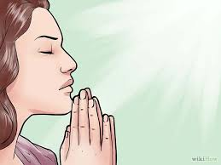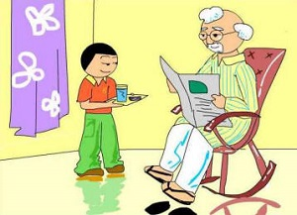
3.
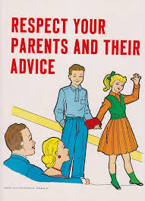

1.________________________________________________________________________

2.________________________________________________________________________

3.________________________________________________________________________

4.________________________________________________________________________

5.________________________________________________________________________

6.________________________________________________________________________

