DELHI PUBLIC SCHOOL, SRINAGAR
REVISION WORKSHEET
SUBJECT: MATHEMATICS
CLASS: IV
Q1. Explore it……….
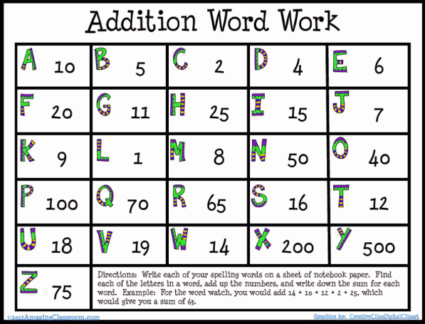

Q2. Add the following.
- 4585 + 6853 + 10 = __________

- 3571 + 4410 + 11 = __________

- 2942 + 7129 + 25 = __________

- 2684 + 2123 + 52 = __________

- 385 + 7192 + 54 = __________

- 4578 + 7535 + 12 = __________

- 3133 + 2962 + 46 = __________

- 1554 + 1873 + 49 = __________

