DELHI PUBLIC SCHOOL, SRINAGAR
REVISION WORKSHEET
SUBJECT: MATHEMATICS
CLASS: III
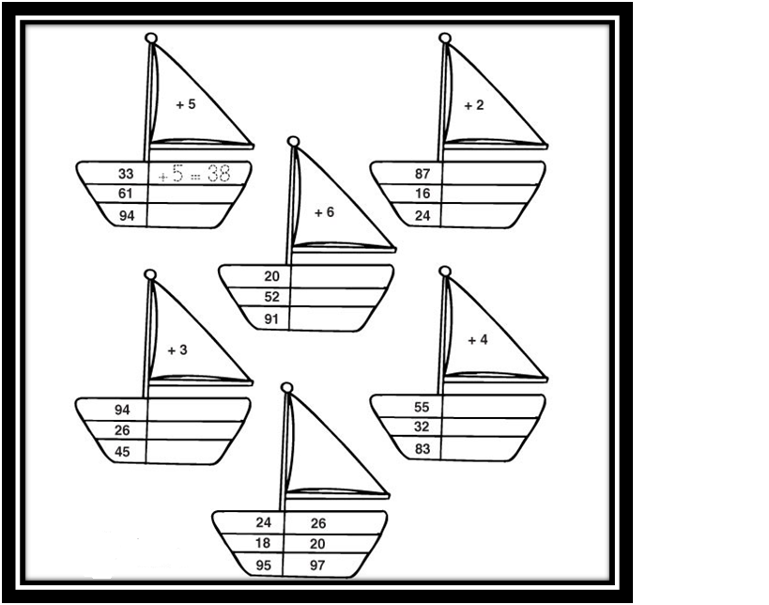
Q1. Finish each addition sentence. Add.

Q2. Solve the following.

