Delhi public school, srinagar.
Revision worksheet -1
CLASS : 1ST
NAME: ___________ DATE:_______________
Q1. Colour as many boxes as the number given in each row.
4
3
9
6
8
1

Q2. Find the missing numbers in each row.
50 |  | 53 |  |  | 56
71 |  |  | 74
 | 92 |  |  | 95
 | 100 | 101

Delhi public school, Srinagar.
Revision worksheet -2
CLASS: 1ST
NAME: ___________ DATE: _______________
Q1. Colour the set with less number of pictures.

Q2. Draw more and colour.
5 more
9 more
12 more

Delhi public school, Srinagar.
Revision worksheet -1
CLASS: II
NAME: ___________ DATE: _______________
Q1. Write the next 5 numbers.
245
314
108
190
299
300
151
111

Q2. Write the previous 5 numbers.
291
304
87
143
200
99
130
312
Delhi public school, Srinagar.
Revision worksheet -2
CLASS: II
NAME: ___________ DATE: _______________
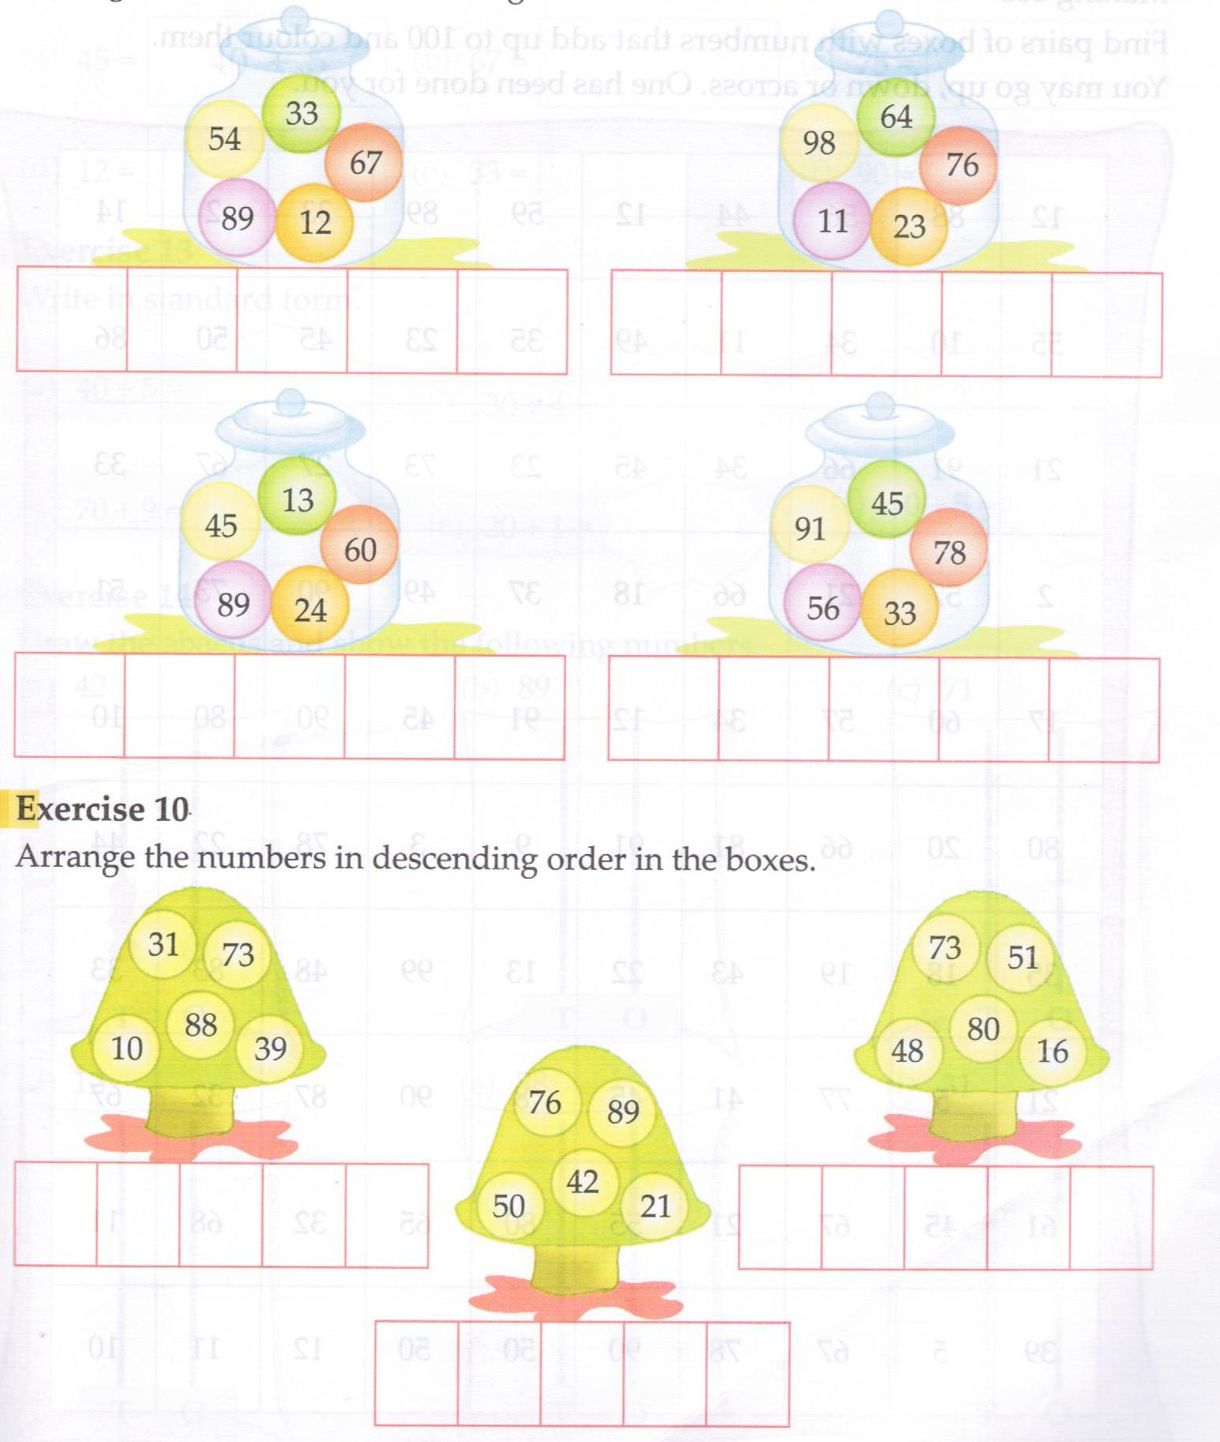
Q1. Arrange the numbers in increasing order.

Q2. Arrange the numbers in decreasing order.

