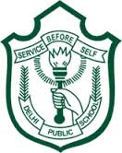
DELHI PUBLIC SCHOOL, SRINAGAR
REVISION WORKSHEET
CLASS: 5TH SUBJECT: EVS
NAME: CLASS & SEC:
Q1. Make a table mentioning different types of teeth & their functions.
Q2.Draw and write about the working & functions of sense organs
Q3.Write yours observation about different forms of energy in your day to day life. Make a list of appliances using different forms of energy
Q4.Draw the molecular arrangement of different states of matter & write 10 examples of each
Q5.Draw a well labeled diagram of a flower

