DELHI PUBLIC SCHOOL SRINAGAR
ASSIGNMENT March 2015
SUBJECT: SCIENCE CLASS: 6th

Q1. Label the different parts of the following plant.
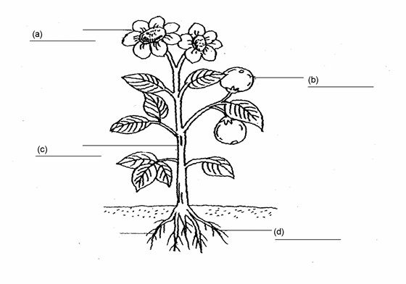
Q2. Draw the diagrams of sprouted moong and chana.

Give reasons for the following questions:
Q3. Do you think it is better to eat a kotari of fat than a kotari of carbohydrates? Why?
Q4. Why should we not eat unknown plants round us even it seem to be edible to us?
Q5. Why should we try to prevent wastage of food?
Q6. Do you feel that food is essential before going to bed?
Q7. Differentiate between carnivores and omnivores.
Q8. What is the difference between edible and non edible parts of the plants?
Q9. Write an activity to show that saliva acts on starch.
Q10. Write a short note on the importance of proteins in our body and explain the effects of eating food deficient of proteins.
Q11. Have you ever observed your mother not washing rice and pulses repeatedly? Find out the reason.
Q12. A table given below in which names of the animals have been given and food they eat are in blank space. Fill the blank spaces.
Name of the animal | Food the animal eat
Buffalo
Cat
Lion
Tiger
Spider
House lizard
Cow
Human being
Butterfly
Crow

