Give me a lever enough and a fulcrum on which to place it, and I shall move the earth.
---- Archimedes

SOURCES OF ENERGY
ENERGY
The ability of a body to do work is called energy. It is measured by the amount of work hat a body can do. It is a scalar quantity and its SI unit is Joule.

FUEL AND ITS USES:
A fuel is defined as any substance which burns easily to produce energy. e.g., coal, petrol, kerosene, natural gas, charcoal, wood, etc are fuels. A good fuel is defined as any substance which burns easily to produce adequate amount of heat energy without giving too much undesirable by-products. e.g., petrol, natural gas, LPG, CNG, Biogas, etc are good fuels. In fact, fuels are the concentrated store of energy. The characteristics of a good fuel are:
- It should produce large amount of useful energy per unit volume or mass.
- It should be easily accessible
- It should be easy and safe to transport, handle and store.
- It should most importantly be economical.
- It should not produce too much objectionable byproducts like harmful or poisonous gases.
- It should have proper ignition temperature.
- It should have moderate rate of combustion

SOURCE OF ENERGY and ITS CHARACTERISTICS
Any system from which useful energy can be obtained or tapped is called a source of energy. Any system from which adequate amount of useful energy can be obtained or tapped at a constant rate at a constant rate without giving too much objectionable byproducts is called a good source of energy. The characteristics of a good source of energy are:
- It should produce large amount of useful energy per unit volume or mass.
- It should be easily accessible
- It should be easy and safe to transport, handle and store.
- It should most importantly be economical.
- It should not produce too much objectionable byproducts like harmful or poisonous gases.

FOSSIL FUELS
Fossil fuels are defined as the fuels preserved under the earth’s crust as the remains of plants and animals. They are the rich compounds of carbon which were originally made by the plants with the help of solar energy. Typical examples of fossil fuels are petroleum, coal and natural gas.
Fossil fuels are believed to be formed over millions of years by the burial of plant and animal remains due to unusual sequence of geological processes operating within the earth’s crust. The remains of plants and animals which died millions of years ago were gradually buried deep in the earth and got covered with sediments like sand and mud and were thus locked away from the reach of oxygen. The covers of the sediments prevented their oxidation and decay while the weights of sediments squeezed out water and other volatile materials. In the absence of oxygen and under the continuous combined effect of high pressure, heat and bacteria, these buried remains of plants and animals are converted into fossil fuels like petroleum, coal and natural gas. The buried remains of large plants and animals are believed to form petroleum and natural gas.
Disadvantages of burning fossil fuels:
- The burning of fossil fuels causes air pollution.
- The acidic oxides released on burning fossil fuels cause acid rain, which affects our water and soil resources.
- The burning of fossil fuels produces green house gases and hence cause green house effect.
- These fuels are non-renewable formed over millions of years.
- The fossil fuels are limited in nature.

Pollution caused by burning fossil fuels can be reduced as follows:
- Increasing the efficiency of the combustion process
- Using various techniques to reduce the escape of harmful gases and ash to the surroundings. e.g, using electrical precipitators, efficient engines, etc.
- Planting more and more trees.
- Using ecofriendly renewable sources of energy.

TURBINE: Turbine is a system consisting of a rotor with assembled blades, which are free to rotate. It is used for converting the kinetic energy of a fluid such as flowing water or a gas into the mechanical energy which inturn is used to run the shaft of the dynamo to generate electricity.

THERMAL POWER PLANT:
Thermal power plant is a power plant in which fuel is burnt to produce heat energy which is then converted into electrical energy. Large amount of fossil fuel are burnt everyday in power stations to heat up water to produce steam, which further runs turbine to generate electricity. The transmission of electricity is more efficient than Transporting coal or petroleum over same distance, therefore many thermal power plants are set up near coal or oil fields.

BIOMASS AS A FUEL.
Greek words ‘bio’ means living and ‘mass’ means material. Thus, the waste material contained in the bodies of the living organisms like pants and animals is called BIOMASS. When organisms like plants die, their biomass can be used as a fuel for domestic purposes. In fact biomass like wood, agricultural wastes and cowdung together supply about 80% of our domestic energy needs in the rural areas. Wood and some agricultural wastes are also used as a fuel in industries. For e.g. bagasse is used in industrial boilers. Bagasse is the sugarcane from which juice has been extracted. In most our villages, biomass like wood are used as fuel in open furnace called chulhas.
The disadvantages of using biomass as a fuel are:
- These fuels do not produce much heat.ie, they have low calorific value.
- A lot of smoke is given when they are burnt.
- Technological inputs are necessary to improve the efficiency of these fuels.
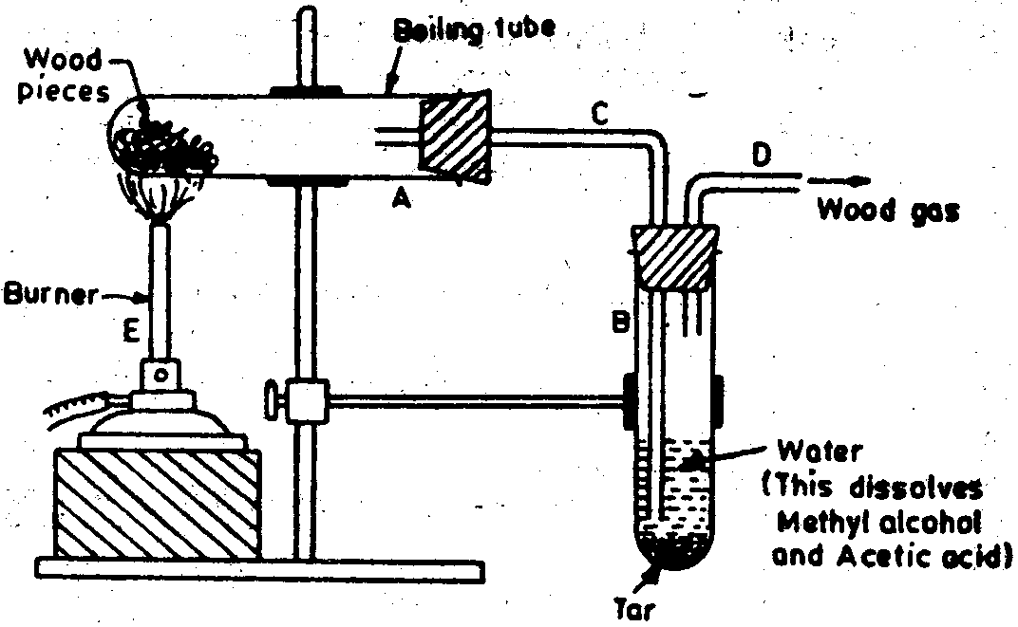
DESTRUCTIVE DISTILLATION OF WOOD (OR) FORMATION OF CHARCOAL
Burning or heating of a substance in limited supply of oxygen is called destructive distillation.
Charcoal is a form of carbon obtained by the destructive distillation of wood. i.e, by burning wood in the insufficient supply of air. When wood is strongly heated in the insufficient supply of air, the volatile substances present in it are expelled leaving behind a black residue called charcoal. When a solid organic compound is heated in a controlled supply of air, it leaves behind a grey residue commonly called charcoal. Charcoal is used as a fuel in house hold, as a reducing agent and in decolourizing sugarcane juice. It is a good composite fuel.

CHARCOAL IS A BETTER FUEL THAN WOOD
Charcoal is a better fuel than wood because of the following reasons:
- Charcoal burns without flame.
- Charcoal has high calorific value than wood i.e., Charcoal produces more heat on burning than an equal mass of wood. For example, 1 gram of charcoal produces 33 kJ of heat energy on burning whereas 1 gram of wood produces only about 17 kJ of heat energy.
- Charcoal is a smokeless fuel i.e., it does not produce any smoke while burning and hence does not cause any pollution on doors. On the other hand, burning of wood produces a lot of smoke which pollutes air.
- It is a compact fuel and therefore is easy to handle and store and convenient to use than wood.
BIOGAS AND ITS FORMATION
Biogas is a mixture of gases like methane, carbon dioxide, hydrogen and hydrogen sulphide. The major constituent of biogas is methane gas. In fact, biogas contains about 65% of methane.
Animal and plant wastes are easily degraded by anaerobic microorganisms like anaerobic bacteria in the presence of water to form gases such as methane, CO₂, H and H₂S. This mixture of gases is called biogas. The process of formation of biogas by the action of anaerobic microorganisms on animal and plant wastes is called fermentation. When obtained from animal dung, then it is called gobar gas and when it is obtained from sewage, it is called sewage gas. This gas can be used for various purposes.
Biogas an ideal fuel and a boon to the farmers: This is because of the following reasons:
- Biogas is an excellent fuel as it contains upto 75% methane.
- It burns without producing any harmful or poisonous gases and smoke.
- It has high calorific value (30-40 KJ/g) i.e., it produces more heat on burning.
- It has proper ignition temperature i.e., its ignition temperature is neither be too high nor too low.
- The slurry left behind in the biogas plants is rich in nitrogenous and phosphorous compounds and hence is used as manure by farmers in their fields.
- It is also used as a fuel to run engines of water pumping sets required for irrigation.
- It has moderate rate of combustion. i.e., it burns smoothly.
- It can be used by the farmers for lighting in homes as well as for street lighting in some places.
- It is safe to transport, easy to handle and convenient to store. It is supplied by pipes directly from the biogas plant.
- Biogas plant provides a safe and efficient method of waste disposal.

BIOGAS PLANT:
Biogas plant is a system where biogas is produced on a large scale. A large sized biogas plant which supplies biogas to many houses in a village is called Community Biogas Plant. The cost of installing such a biogas plant is shared by the people in the village community. All the cattle dung from many houses in the villages is used to feed the plant. The biogas is then supplied to all the houses in the village through pipes.
There are two designs of community biogas plants: Fixed Dome Type Biogas Plant and Floating Gas Holder Type Biogas Plant.
Construction And Working Of Fixed Dome Type Biogas Plant:
A fixed dome type biogas plant is a unique type of biogas plant in which a gas holder and the digester are as one single unit and can be constructed by laying bricks. It has a longer life than the floating type biogas plant.
It consists of following parts:
i.. A well shaped underground tank called digester. It is made up of bricks.
ii. A dome shaped roof which acts as a storage tank for biogas. It is also made up of bricks.
iii. A mixing tank connected to the left of the digester through a sloping inlet chamber made of bricks.
iv. An overflow tank connected to the right of the digester through an outlet chamber made of bricks.
v. A Gas outlet at the top of the dome having gas valve ‘V’.
Slurry is made by mixing cattle dung and water in equal proportions in a mixing tank. This slurry is fed into the digester through the inlet chamber. The slurry is left in the digester for 50-60 days in the digester. During this period, anaerobic bacteria and other microorganisms present in the dung carry out its degradation. As a result a mixture of gases called biogas is evolved which begins to collect in the dome. Due to increased pressure of the gas, the spent slurry is forced out through outlet chamber into the overflow tank. This spent slurry is taken out and used as manure because it is rich in Nitrogen and phosphorous compounds. The gas is taken out through the gas outlet and is distributed to the houses through the gas pipes. When pressure falls the fresh slurry is added to the digester and continuous supply of biogas is maintained.
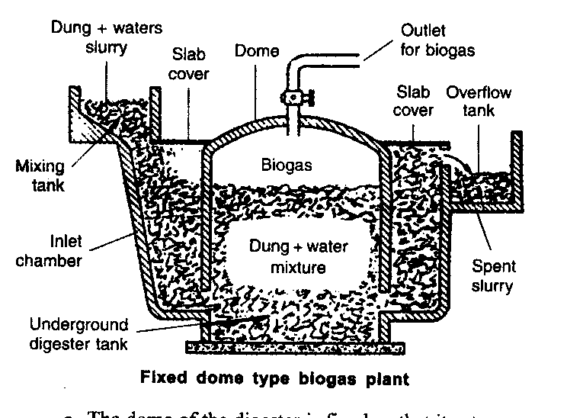

Construction and working of the Floating Gas Holder type biogas plant.
A Floating Gas Holder type biogas plant is a type of biogas plant in which a gas holder and the digester are not as one single unit. It consists of following parts:
i. A well shaped underground tank called digester. It is made up of bricks.
ii. A cylindrical drum shaped gas holder roof which acts as a storage tank for biogas. It is also made up of steel. It floats in the inverted position over the slurry.
iii. A mixing tank connected to the left of the digester through an inlet pipe made of steel.
iv. An overflow tank connected to the right of the digester through an outlet pipe made of steel.
v. A Gas outlet at the top of the gas holder having gas valve ‘V’.
vi. A partition wall which divides the digester into two parts.
The working of Floating Gas Holder type biogas plant is same as the working of fixed dome type biogas plant.

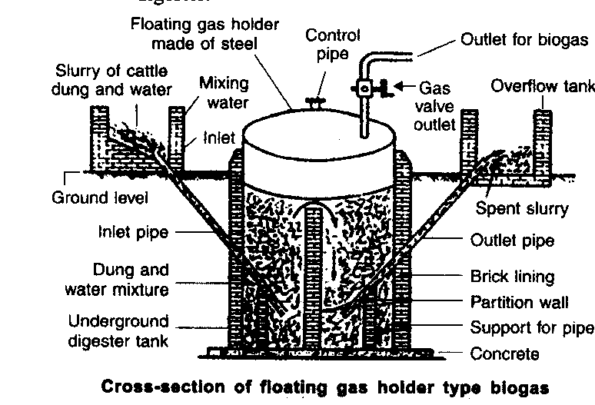

HYDROELECTRICITY
The electricity generated by using the kinetic energy of flowing water in rivers or the potential energy of water stored in a dam is called is called hydroelectricity. The arrangement in which the kinetic energy of flowing water is converted into electricity is called hydro power plant. Hydroelectricity is an indirect source of solar energy.
Principle of generation of Hydroelectricity: in order to produce hydroelectricity, high rise dams are constructed on the river to obstruct the flow of water and thereby collect the water in the reservoirs. The water level rises and in the process kinetic energy of the flowing water gets transformed into potential energy. The water from the high level is carried through the pipes to the turbine at the bottom of the dam. When the fast flowing water falls on the turbine, the kinetic energy of the water rotates the turbine rapidly, which in turn rotates the coil of the generator to generate electricity.
Advantages of hydroelectricity:
- Hydroelectricity is a natural and renewable source of energy and hence we need not to worry about hydroelectric sources getting used up.
- It is ecofriendly source of energy if proper precautions are taken while constructing dams.
- It is cheap source of energy except for initial investment.
Disadvantages of hydroelectricity:
- The dams can be constructed only in a limited number of places, preferably in hilly areas.
- Large areas of agricultural land and human habitation are to be sacrificed as they get submerged.
- Large ecosystems are destroyed when submerged under the water in dams.
- The vegetation which is submerged rots under anaerobic conditions and gives rise to large amounts of methane which can cause green house effect.
- It also creates the problem of satisfactory rehabilitation of displaced people. Opposition to the construction of Tehri dam on the river Ganga and Sardar Sarovar project on the river Narmada are due to such problems.

WIND ENERGY
The moving air is called wind. The kinetic energy associated with the wind is called wind energy. Wind is caused due to unequal heating of the land masses and the water bodies by the solar radiation. The uses of wind energy are:
- The kinetic energy of the wind can be used to do work. This energy was harnessed by windmills to do mechanical work like to lift water from a ell, to grind grains in flour mills, etc.
- It is also used these days to generate electricity with the help of wind mill.
- It is also used to run sail boats.
Advantages of wind energy:
- It is an ecofriendly source of energy.
- It is an efficient source of renewable energy.
- It requires no recurring expenses for the production of electricity.
Disadvantages of wind energy:
- Wind energy farms can be established only at those places where wind blows for greater part of a year.
- The wind speed should also be higher than 15 km/h to maintain the required speed of the turbine.
- Furthermore, there should be some backup facilities like storage cells to take care of the energy needs during a period when there is no wind.
- Establishment of wind energy farms requires large areas of land. For a 1 MW generator, the farm needs about 2 hectares of land.
- The initial coat of establishment of the farm is quite high.
- Moreover, since the tower and the blades are exposed to the vagaries of nature like sun, storm and cyclone, they need a high level of maintenance.

Wind mill and wind energy farm:
A windmill is an arrangement which uses wind energy to do mechanical work or to generate electricity. It essentially consists of a structure similar to a large electric fan that is erected at some height on a ground. To generate electricity, the rotatory motion of the windmill is sued to run the turbine of the electric generator. The out put of a single wind mill is quit small and cannot be used for the commercial purposes. Therefore, a number of windmills are erected over a large area to get the energy output on a commercial scale. This arrangement of a number of windmills erected over a large area to get the energy output on a commercial scale is called wind energy farm. Denmark is called country of winds because more than 25% of their electricity is generated through windmills.
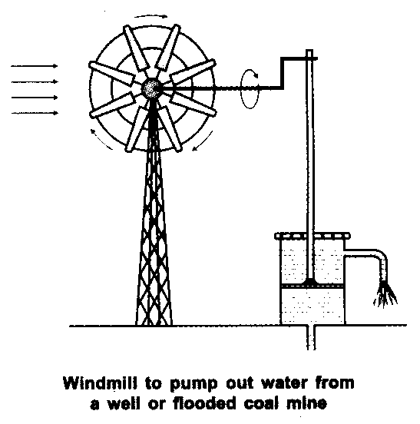

SOLAR ENERGY
The energy radiated by the sun in the form of electromagnetic radiations is called solar energy. It includes light radiations, infra red radiations and ultra violet radiations. Two thirds of solar energy consists of infra red rays. The sun has been radiating an enormous amount of energy at he present rate for nearly 5 billion years and will continue to do so for about 5 billion years more. Only a small part of the solar energy reaches the outer layer of the earth’s atmosphere. Nearly half of it is absorbed while passing through the atmosphere and the rest reaches the earth’s surface.
It is the inexhaustible source of energy. The various functions performed by the sun’s energy on the earth are:
- Solar energy powers the flow of winds.
- It powers the flow of water cycle on earth.
- It provides energy for preparing food by the process of photosynthesis by plants and hence sustains life on earth.
- Sun’s energy created the fossil fuels over a period of millions of years.
- It provides light and warmth on earth.
- Nowadays, it is used in devices like solar cookers, solar heaters and solar cells.

Does all the energy radiated by the sun reach the earth’s surface:.
Every square metre of the earth’s upper atmosphere receives 1.4 kJ of energy per second. This is called solar constant. The solar energy reaching unit area at the outer edge of the earth’s atmosphere exposed perpendicularly to the rays of the sun is known as solar constant. It is estimated to be approximately 1.4 KJ/S/m² or 1.4kw/ m². But all this energy does not reach the surface of earth. Some of the sunlight is reflected back into space, some is absorbed by water vapour, ozone, dust, CO₂ and other gases present in the atmosphere. In fact, only 47% of the sun’s energy that strikes the earth’s atmosphere reaches the earth’s surface and is absorbed. Even this fraction of sun’s energy is quite substantial.

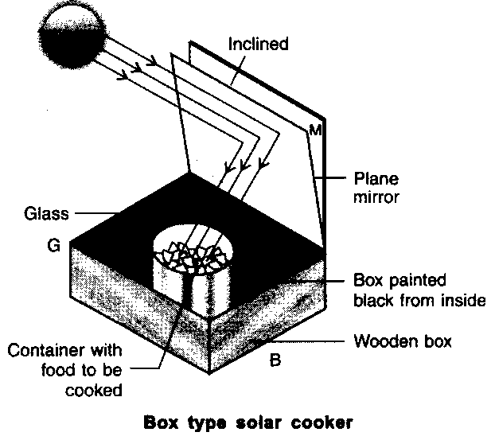
SOLAR COOKER
Solar cooker is a solar heating device which uses solar energy for cooking food. It consists of an insulated metal box or wooden box, which is painted black from inner side. Black surface absorbs as well as radiates more heat. The top of the ox is covered by a thick glass sheet so that the radiated heat does not escape from the box. This effect is called green house effect. A mirror adjusted at a suitable angle acts as a reflector so that more and more heat enters the box. The food to be cooked is placed in steel containers painted black from outside. When the solar cooker is kept in the sunlight, the solar energy enters the box and is absorbed by the box. The glass sheet does not allow the radiated heat to escape from the box and as a result the temperature inside the ox rises to about 100ºC -150 ºC. Thus, the food in the containers gets cooked.
The limitations of solar cooker :
- Solar cookers are useful only at certain times during the day.
- They cannot be used efficiently on a rainy or foggy day.
- They cannot be used during night.
- The reflector needs to be adjusted all the time.

SOLAR CELL
Solar cell is a device that converts solar energy into electrical energy. It is also called photovoltaic cell. A typical soar cell develops a voltage of 0.5 to 1 volt and can produce about 0.7 watts of electricity when exposed to sun. Solar cells are made of semi conducting materials like silicon, selenium, germanium, etc with added impurities. The arrangement of a large number of solar cells to deliver energy for practical use is called solar panel.

Advantages of solar cells:
- They have no moving parts.
- They require little maintenance.
- They work quite satisfactorily without the use of focusing device.
- They can be set up in remote and inaccessible hamlets or very sparsely inhabited areas in which laying of power transmission line may e expensive and not commercially viable.
- They use a renewable source of energy.
Disadvantages of solar cells
- Silicon, which is used for making solar cells, is abundant in nature but the availability of the special grade silicon needed for making the solar cells is limited.
- The entire process of manufacture is very expensive.
- Silver is used for interconnection of cells in the solar panel, which further adds to the cost.

Give me a lever enough and a fulcrum on which to place it, and I shall move the earth.
---- Archimedes

SOURCES OF ENERGY

DIFFERENCE BETWEEN NUCLEAR REACTION AND CHEMICAL REACTION:

Chemical reaction | Nuclear reaction
1. The reactions in which the valence electrons are involved but nuclei of atoms do not undergo any change are called chemical reactions. For e.g., when Na and Cl react, they form sodium chloride.  Na + Cl NaCl  2. In a chemical reaction, the chemical identity of an atom does not change. i.e., no new element can be produced. Only the rearrangement of atoms takes place with the formation of new products.  3. A small amount of energy is released or absorbed in a chemical reaction in the form of heat and light.  4. It is reversible under suitable conditions. | 1. The reactions in which the valence electrons are not involved but nuclei of atoms undergo a change are called nuclear reactions. For e.g., when nitrogen gas is bombarded with alpha particles, it results in the formation of oxygen and a proton.  ₇N¹⁴ + ₂He⁴ ₈O¹⁷ + ₁H¹  2. In a nuclear reaction, the chemical identity of an atom not changes. i.e., new elements can be produced due to the change in the number of nucleons in the nucleus of an atom.  3. A tremendous amount of energy is released or absorbed during nuclear reactions.  4. It is irreversible.

FORCES OPERATING INSIDE THE NUCLEUS
There are two types of forces operating inside the nucleus of an atom. These forces are electrostatic force and nuclear force.
Electrostatic force of repulsion: It is the force of repulsion that exists between the positively charged protons present in the nucleus. Due to this force protons in the nucleus repel each other and hence tend to make the nucleus unstable. It is a long-range force.
Nuclear force: It is the force of attraction that exists between two protons or two neutrons or a proton and a neutron present in the nucleus. It is a very strong attractive force which tends to make the nucleus stable. Nuclear force is a short rang force. i.e., it is effective only when the nucleons are very close together as in a small nucleus.
In a small nucleus, the protons and neutrons are very close together due to which the nuclear force of attraction is very strong than the electrostatic force of repulsion. Since the nuclear force of attraction dominates in a small nucleus, the small nucleus is very stable.
On the other hand, in a large nucleus like U-235 the distances between the nucleons (protons and neutrons) are greater. Due to this the electrostatic force of repulsion tends to dominate nuclear force of attraction. This makes the heavy nucleus unstable. Thus, the atoms having large nucleus like U-235 atom is held in delicate balance and can rupture even when slightly disturbed.

What happens when U-235 is bombarded with a slow moving neutron? Explain with the help of a diagram.
The nucleus of U-235 is large and is highly unstable. It is held in a delicate balance and can rupture even when slightly disturbed. A slow moving neutron colliding with a U-235 nucleus can rupture the nucleus completely to form smaller nuclei of barium and krypton with the emission of 3 neutrons and a large amount of energy. The rupture of nuclear fission of U-235 nucleus is diagrammatically shown as follows:
When an extra neutron enters the highly unstable nucleus of a U-235 atom, it completely upsets the delicate balance between the electrostatic and nuclear forces. The nucleus gets elongated and develops a slight depression (waist) and then a neck develops. The coulombic repulsion between the two portions helps in breaking the nucleus. Finally, the nucleus of U-235 atom splits into smaller fragments like Barium, krypton and 3 neutrons. A huge amount of energy is also released in this process..
.
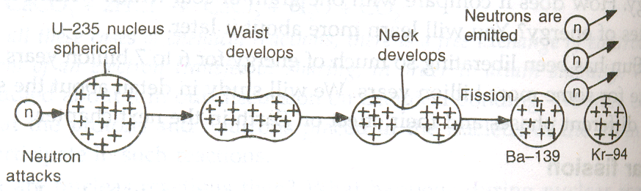

NUCLEAR RESEARCH CENTRES AND NUCLEAR POWER PLANTS IN INDIA.
In India, the major nuclear research centres are located at: (i) Baba atomic research centre at Trombay in Maharashta, (ii) atomic research centre at Gulmarg in Kashmir and (iii) nuclear research centre in Calcutta.
In India, the atmic power stations are located at : (i) Tarapur in maharashtra, (ii) Kota in Rajasthan, (iii) Kalpakkam in Tamil Nadu and (iv) Bulandshahar in Uttar Pradesh

DIFFERENCE BETWEEN NUCLEAR FISSION AND NUCLEAR FUSION.

NUCLEAR FISSION:
- The process in which a heavy unstable nucleus splits into two lighter nuclei of medium weights with the liberation of large amount of energy is called nuclear fission. The two new nuclei formed are called fission fragments and the heavy nucleus which splits is called parent nucleus and the particle which brings about fission is called projectile.
- Nuclear fission is carried out by bombarding the heavy nucleus like U-235 with suitable projectiles like a slow moving neutron. It takes place at ordinary temperature.
- For example when U-235 atoms are bombarded with slow moving neutrons, the heavy U-atom first changes into highly unstable U-236 and then splits up into two fragments like Ba-139 and Kr-94 with the emission of two or three neutrons.
₀n¹ + ₉₂U²³⁵ ₅₆Ba¹³⁹ + ₃₆Kr⁹⁴ +3₀n¹ + energy
- It is a chain reaction and such a reaction takes place in an atom bomb.
- It produces large quantities of radioactive wastes which are harmful and hence causes more dangerous radioactive pollution.

NUCLEAR FUSION:
- The process in which two lighter nuclei combine to form more stable nucleus with the liberation of enormous amount of energy is called nuclear fission. The two new nuclei which fuse together are called daughter nuclei and the heavy nucleus formed is called product nucleus.
- Nuclear fusion can be carried out at very high temperature (~ 10⁷K).
- For example, when two deuterium atoms are heated to a very high temperature of about 10⁷K , then the two deuterium nuclei fuse together to form more stable and heavy helium nucleus with the liberation of enormous amount of energy.
₁H² + ₁H² ₂He³ + enormous energy
- It is not a chain reaction and such a reaction takes place in hydrogen bomb and in the sun.
- It does not produce radioactive wastes and hence does not cause radioactive pollution.

DIFFERENCE BETWEEN ATOM BOMB AND HYDROGEN BOMB:
Atom bomb | Hydrogen bomb
1. Atom bomb is a nuclear device based on the principle of uncontrolled nuclear fission. It is also called fission bomb.  2. In atom bomb uncontrolled fission of nuclear fuel like U-235 takes place liberating a large amount of energy.  3. The fissile materials used in the atom bomb are U-235 and Pu-239.  4. The products in the atom bomb are highly radioactive and high energy radiations are given out.  5.It produces a large amount of energy and is very destructive. | 1. Hydrogen bomb is a nuclear device based on the principle of nuclear fusion. It is also called fission-fusion bomb or thermonuclear bomb.  2. In Hydrogen bomb nuclei of hydrogen fuse to form stable helium nucleus liberating enormous amount of energy.  3. The fuel used in the Hydrogen bomb is a mixture containing all three isotopes of hydrogen.  4. The products in the Hydrogen bomb are not radioactive.  5. It produces much more energy than atom bomb.
Labelled and schematic diagram of a nuclear reaction taking place in U-235 nucleus.
A reaction in which a particle which starts the reaction is produced during the reaction to continue the reaction further and further is called chain reaction. It is a self sustaining or self propagating reaction because once started it goes on propagating by itself until one of the reactants is all used up. For example, fission of U-235 by means of slow moving neutrons is a chain reaction
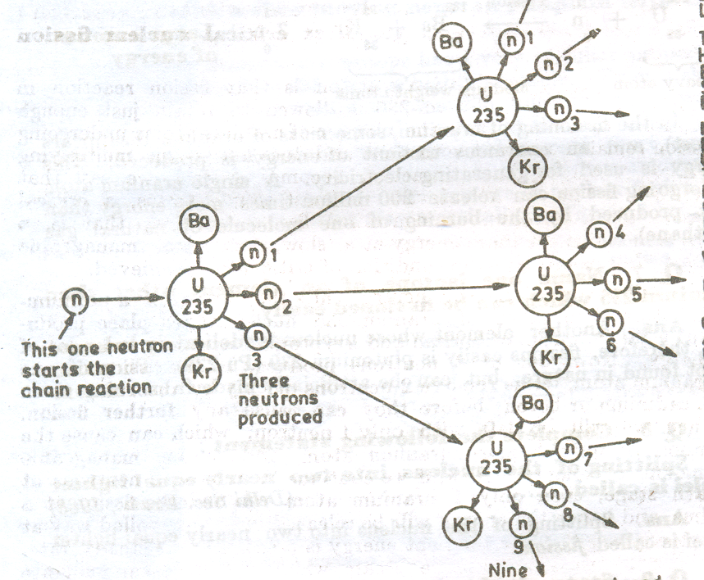

CONTROLLED FISSION REACTION
A critical fission reaction is that fission reaction in which fission of U-235 is allowed to retain just enough neutrons to ensure that the number of uranium atoms undergoing fission remains constant. It is also called controlled fission reaction because energy is released at a slow, steady and manageable rate.
Critical fission reaction is carried out by removing or absorbing two of the three neutrons produced in fission with help of boron and cadmium rods. Enrico Fermi carried out the first critical fission reaction on 2nd December 1942 at the Chicago University in U.S.A.

SCHEMATIC DIAGRAM OF A NUCLEAR POWER PLANT.
Nuclear power plant is a power plant where electricity is generated by using nuclear energy. It consists of nuclear reactor, heat exchanger, turbines and a condenser with a pump.
The nuclear reactor further consists of shield, fuel rods, coolant and moderator.
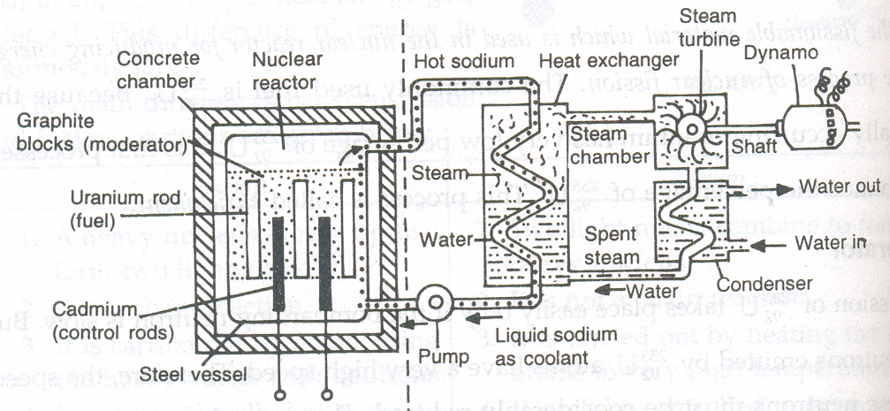 First the fuel rods of cadmium and boron are put fully inside the core of reactor and the fuel rods of U-235 are inserted into the reactor. The reactor is then sealed. The enriched uranium core is then subjected to nuclear fission by slow moving neutron. The fissionable material is stacked with heavy water or graphite which is used as moderators to slow down the neutrons produced in the fission. The control rods absorb the excess neutrons produced. They are slowly raised till criticality is achieved. The controlled fission produces a lot of heat which is transferred to heat exchanger by coolant like heavy water or liquid sodium. In heat exchanger the energy is used to convert water into steam. The steam produced is used to run a turbine to generate electricity. The spent steam is then cooled in the condenser. The shield around the reactor prevents heat or radiation leakage.

HARMFUL EFFECTS OF NUCLEAR ENERGY:
i. Nuclear fission emits harmful nuclear radiations which can cause irreparable damage to tissue cells and cause skin cancers, leukemia, etc.
ii. The nuclear wastes generated during nuclear fission are radioactive and cannot be disposed off easily. Nowadays, they are being disposed in leak-proof lead containers. No such problem arises in using fossil fuels.
iii. Nuclear power plants cannot be located near the population.
iv. A nuclear power plant has to have number of safety measures, which makes the construction of the plant expensive.

Methods To Minimize The Harmful Effects Of Nuclear Radiations
i. Transporting nuclear materials in thick leak-proof containers.
ii. Reactor walls are made of thick lead surrounded by concrete walls.
iii. Nuclear radiation proof dress is used by the workers working in the nuclear power plant.
iv. Special gloves are used by technicians working in nuclear medicine laboratories.
v. Empty containers are disposed off with utmost care by burning them deep inside the earth in remote places.

The advantages of the energy systems using nuclear fission over those using fossil fuels are:
i. Nuclear fission can be controlled and used for constructive purposes like generating electricity on a very large scale.
ii. Nuclear power plants consume very little fuel. Once nuclear fuel like U-235 is loaded into the nuclear power plant, then it will go on releasing energy for 2 to 3 years at a stretch. On the other hand, fossil fuels have to be fed in regularly in the power plant.
iii. If properly used, nuclear power plants produce less atmospheric pollution than the thermal power plants.
iv. A sizeable amount of fuel (U & Pu) can be reclaimed by processing the spent fuel material. In contrast, fuels like coal cannot be reclaimed once they have been used.

What actually powers the sun?
The correct explanation for the source of sun’s energy was provided by a German scientist Hans Bethe in the year 1939. He suggested that the sun contains hydrogen nuclei in its core which are moving at very great speeds. Whenever these hydrogen nuclei fuse to form helium nucleus at high temperature of the order of 10⁶ K, a tremendous amount of energy is released. Thus, it is the energy produced by nuclear fusion of hydrogen into helium that actually powers the sun.
GEOTHERMAL ENERGY
'Geo' means 'earth' and 'thermal' means 'heat'. Thus, geothermal energy is the heat energy from hot rocks present inside the earth. This heat can be used as a source of energy to produce electricity. Geothermal energy is one of the few sources of energy that do not come directly or indirectly from solar energy (or sun's energy). The places where very hot rocks occur due to collection of hot magma at some depth below the surface of earth are called 'hot spots' and are sources of geothermal energy. This energy heats the underground water. The regions where hot underground water comes out of the earth’s crust are called hot springs or geysers.
Harnessing of Geothermal Energy:
The extremely hot rocks present below the surface of earth heat the underground water and turn it into steam. As more and more steam is formed between the rocks, it gets compressed to high pressures. A hole is drilled into the earth upto the hot rocks and a pipe is put into it. The steam present around the hot rocks comes up through the pipe at high pressure. This high pressure steam turns the turbine of a generator to produce electricity.
Sometimes two holes are drilled into the earth in the region of hot rocks and two pipes are put into them. Cold water is pumped in through one of the pipes. This cold water is turned into steam by the hot rocks. The steam thus formed comes out through the other pipe and used to generate electricity.
Advantages Of Geothermal Energy: Some of the advantages of using geothermal energy are as follows:
  - It is economical to use geothermal energy. This is because the cost of electricity produced by using geothermal energy is almost half of that produced from conventional energy sources.
  - Another advantage is that the use of geothermal energy does not cause any pollution. So, it is a clean and environment friendly source of energy.
  - It can be used 24 hours throughout the year.
Disadvantages Of Geothermal Energy: Some of the disadvantages of geothermal energy are as follows:
- Geothermal energy is not available everywhere.
- It is available only in those areas where there are hot rocks near the earth's surface.
- Another disadvantage is that deep drilling in the earth to obtain geothermal energy is technically very difficult and expensive.
Note: In our country there are a very limited number of places where geothermal energy can be harnessed on a commercial scale. Two places where geothermal energy can be exploited on commercial scale are located in Madhya Pradesh and Himachal Pradesh. In USA and Newzealand, a number of geothermal energy power plants are working successfully.

ENERGY FROM THE SEA
The energy from the sea can be obtained mainly in three forms:
(i) Tidal energy,
(ii) Wave energy, and
(iii) Ocean thermal energy.

TIDAL ENERGY:
Tidal Energy the alternate rise and fall of sea water twice a day are known as tides. Tides are caused due to the gravitational pull of the moon and to some extent of sun. The rise of sea water is called "high tide" whereas the fall of sea water is called "low tide." The tidal waves in the sea build up and recede (rise and fall) twice a day. The kinetic energy of moving water of oceans during tides is called tidal energy.

Harnessing tidal energy: The tidal energy can be harnessed by constructing a tidal barrage or tidal dam across a narrow opening to the sea.During high tide, when the level of water in the sea is high, sea-water flows into the reservoir of the barrage and turns the turbines. The turbines then turn the generators to produce electricity. And during the low tide, when the level of sea-water is low, the sea-water stored in the barrage reservoir is allowed to flow out into the sea. This flowing water also turns the turbines and generates electricity. Thus, as sea-water flows in and out of the tidal barrage during high and low tides, it turns the turbines to generate electricity.
Limitations Of Tidal Energy: The tidal energy is not likely to be a potential source of energy in future because of the following reasons:
(i) There are very few sites around the world which are suitable for building tidal barrages (or tidal dams).
(ii) The rise and fall of sea-water during high tide and low tide is not enough to generate electricity on a large scale.

SEA WAVE ENERGY:
Due to the blowing of wind on the surface of sea, very fast seawaves (or water waves) move on its surface. Due to their high speed, sea-waves have a lot of kinetic energy in them. The kinetic energy of moving sea-waves is called sea wave energy. It can be used to run the turbine of a generator to generate electricity. A wide variety of devices have been developed to trap sea-wave energy to turn turbines and drive generators for the production of electricity.
(i) One idea is to set-up floating generators in the sea. These would move up and down with the sea-waves. This movement would drive the generators to produce electricity.
(ii) Another idea is to let the sea-waves move up and down inside large tubes. As the waves move up, the air in the tubes is compressed. This compressed air can then be used to turn a turbine of a generator to produce electricity.

Limitations Of sea wave energy are:
- Models have beep made to harness this energy but it will be many years before full-size wave-energy generators can be built to harness the sea-waves energy on a large scale.
- The harnessing of sea-waves energy would be a viable proposition only at those places where sea-waves are very strong.

OCEAN THERMAL ENERGY (OTE):
A very large area of sea is called an ocean. The water at the surface of an ocean gets heated by the heat of the sun and attains a higher temperature than the colder water at deeper levels in the ocean. So, there is always a temperature difference between the water "at the surface of ocean" and "at deeper levels." The energy available due to the difference in the temperature of water at the surface of the ocean and at deeper levels is called ocean thermal energy (OTE). Ocean thermal energy is one of the forms in which solar energy manifests itself in oceans. The ocean thermal energy can be converted into a "usable form" of energy like electricity.
Harnessing Ocean Thermal Energy (OTE): The devices used to harness ocean thermal energy are called Ocean Thermal Energy Conversion power plants (or OTEC power plants). A temperature difference of 20°C (or more) between the surface water of ocean and deeper water is needed for operating OTEC power plants. In one type of OTEC power plant, the warm surface water of ocean is used to boil a liquid like ammonia or a chlorofluorocarbon (CFC). The high pressure vapours of the liquid (formed by boiling) are then used to turn the turbine of a generator and produce electricity. The colder water from the deeper ocean is pumped up to cool the used up vapours and convert them again into a liquid. This process is repeated again and again.
Advantages of Ocean Thermal Energy:
- A great advantage of the ocean thermal energy is that it can be used continuously 24 hours a day throughout the year.
- Another advantage is that ocean thermal energy is a renewable source of energy.
- Its use does not cause any pollution.

ASSIGNMENT-1
Subject : Physics Name of the student : _________________________
Worksheet : 1 SID : _________________________
Class : X

I. Multiple Choice questions:
i. The component of solar radiations which is responsible for heating effect is:
a) Ultraviolet rays b) infra-red rays
c) Visible light d) All of these
ii. A typical solar cell can generate electricity of about:
a) 14 watt b) 0.14 watt
c) 0.7 watt d) 7 watt
iii. the fraction of sun’s energy received on the earth is about:
a) 47% b) 74%
c) 57% d) 12%
iv. Which of the following has different source than others?
a) Chemical energy in food b) Wind energy
c) Nuclear energy d) Hydro energy
v. Minimum wind velocity required for making a wind mill functional is
a) 15 m/s b) 5 m/s
c) 15 km/h d) 5 km/h

II. Answer the following questions
- What are the limitations of extracting energy from sea waves and tides?
- Draw a schematic diagram of a biogas plant.
- What are the reasons behind Narmada dam running into controversy?
- It was believed that nuclear energy is only destructive. Do you agree? Justify your answer.
- Why is CNG ecofriendly?

- High Order Thinking questions:
- A student constructed a box type solar cooker. He found that it did not work efficiently. Give any two possible mistakes made by the student in its construction/ operation.
- Electricity generated at hydro-electric power stations is considered to be another form of solar energy. Do you agree with the statement? Justify your answer.

