**DELHI PUBLIC SCHOOL, SRINAGAR**

**Athwajan, Srinagar – 190004, J&K**

Phones: 0194 2467286, 2467550 Fax: 0194 2467669

Email: [info@dpssrinagar.com](mailto:info@dpssrinagar.com) Website: [www.dpssrinagar.com](http://www.dpssrinagar.com)

**MATHEMATICS (March-April 2015)**

**Topic : Real Numbers Class : X**

**Concepts**

1. Euclid's Division Lemma

2. Euclid's Division Algorithm

3. Prime Factorization

4. Fundamental Theorem of Arithmetic

5. Decimal expansion of rational numbers

A dividend can be written as, Dividend = Divisor × Quotient + Remainder. This brings to Euclid's division lemma.  
  
**Euclid’s division lemma:**  
Euclid’s division lemma, states that for any two positive integers ‘a’ and ‘b’ we can find two whole numbers ‘q’ and ‘r’ such that a = b × q + r  where 0 ≤ r < b.  
  
Euclid’s division lemma can be used to find the highest common factor of any two positive integers and to show the common properties of numbers.  
  
**The following steps to obtain H.C.F using Euclid’s division lemma:**

1. Consider two positive integers ‘a’ and ‘b’ such that a > b. Apply Euclid’s division lemma to the given integers ‘a’ and ‘b’ to find two whole numbers ‘q’ and ‘r’ such that, a = b x q + r.
2. Check the value of ‘r’. If r = 0 then ‘b’ is the HCF of the given numbers. If r ≠ 0, apply Euclid’s division lemma to find the new divisor ‘b’ and remainder ‘r’.
3. Continue this process till the remainder  becomes zero. In that case the value of the divisor ‘b’ is the HCF (a , b). Also HCF(a ,b) = HCF(b, r).

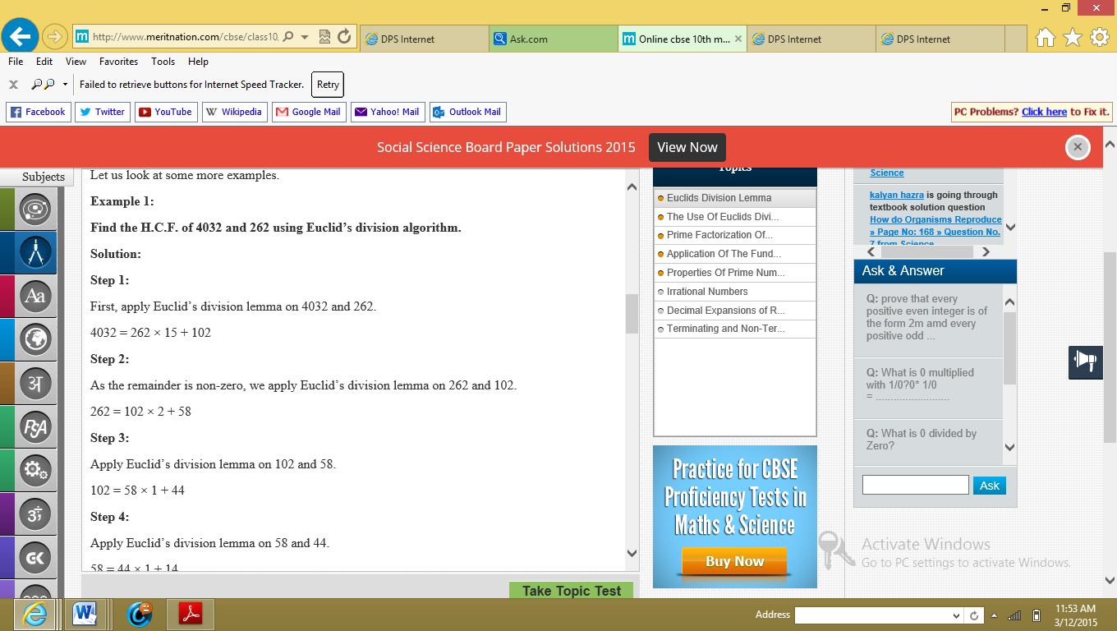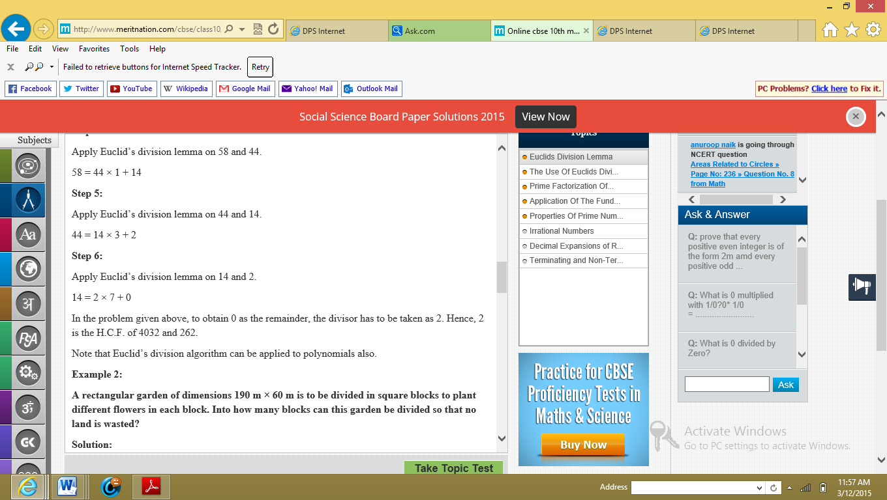

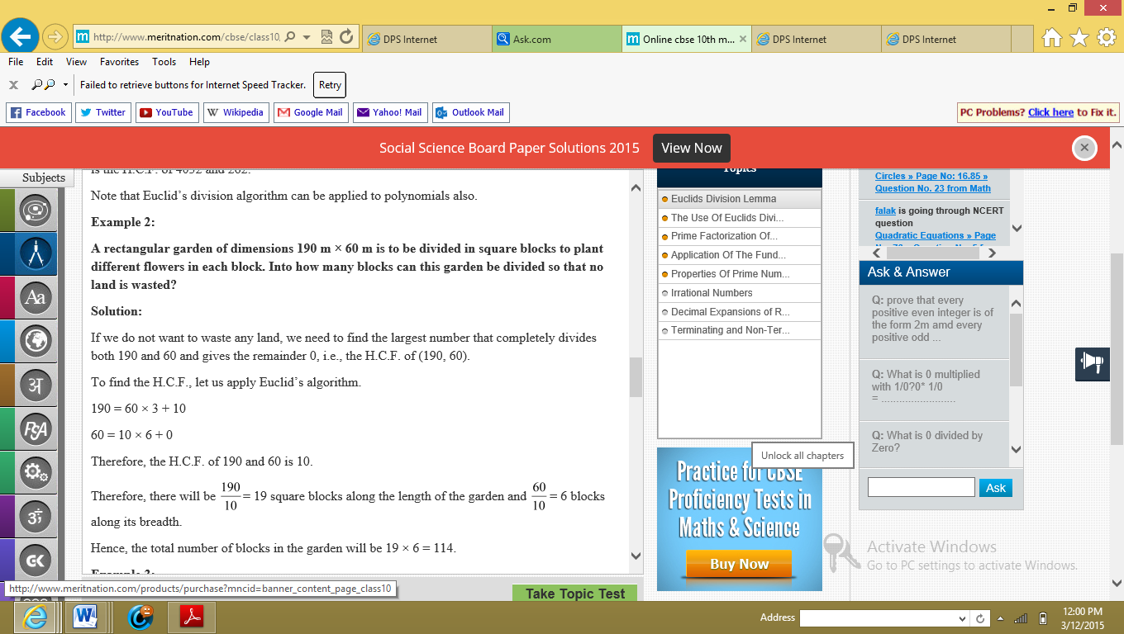

Example 3:

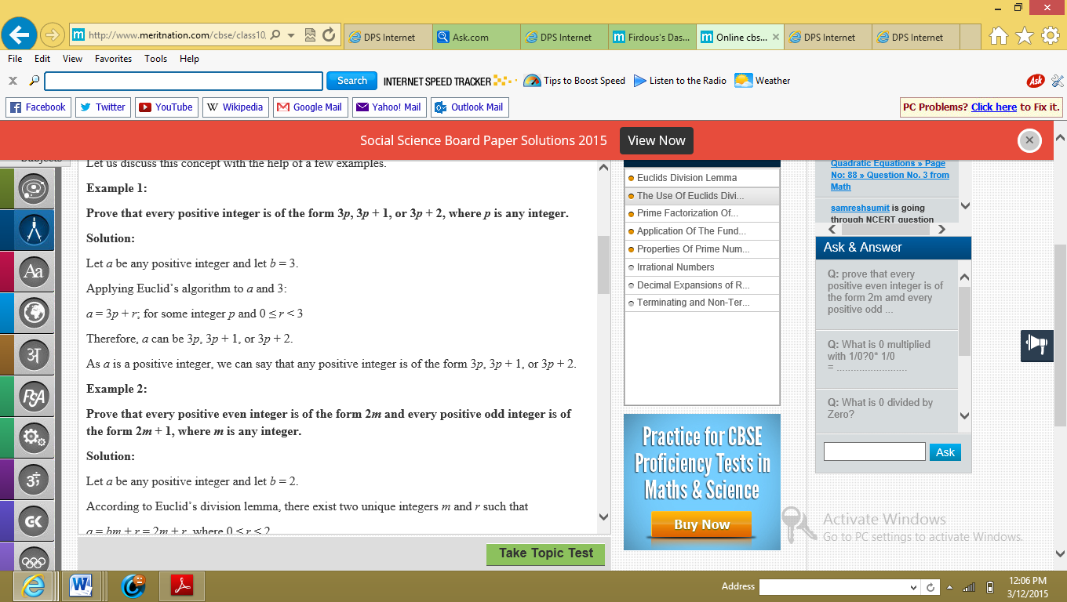

Example 4:

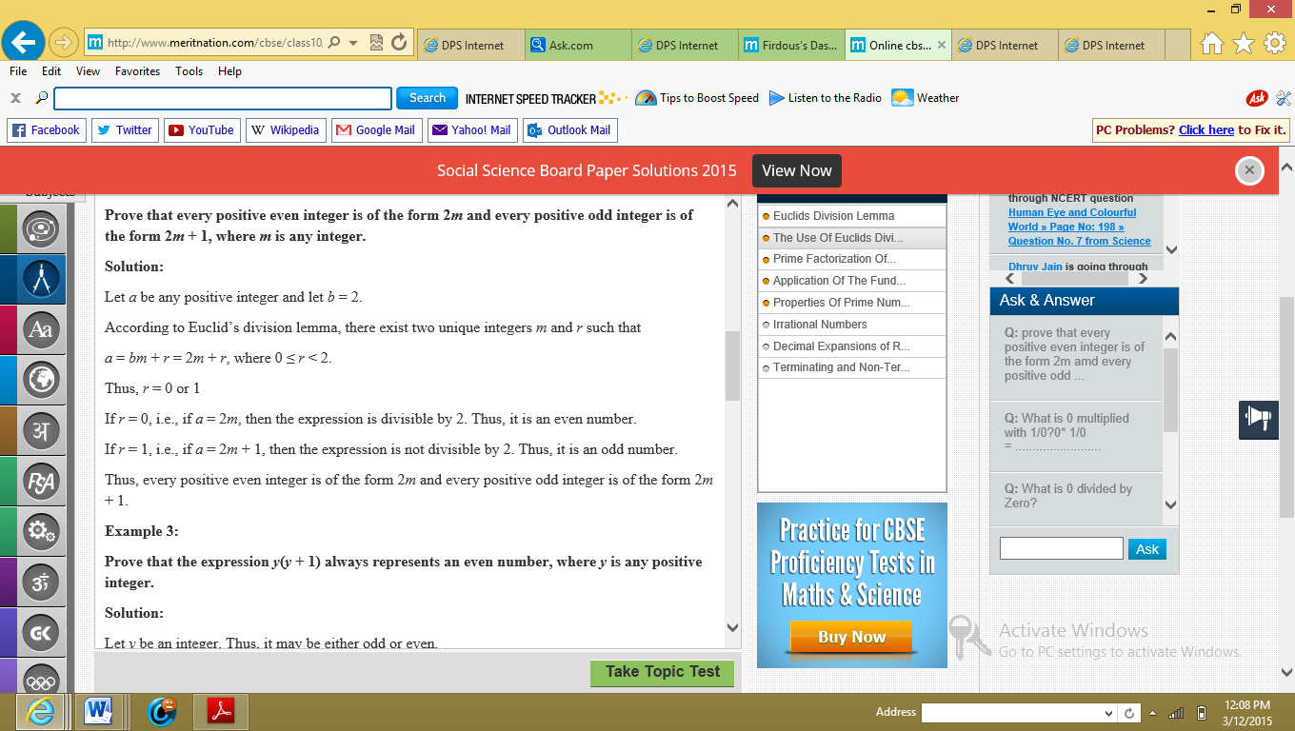

**Fundamental Theorem of Arithmetic:**  
Fundamental Theorem of Arithmetic states that every composite number greater than 1 can be expressed or factorized as a unique product of prime numbers except in the order of the prime factors.

We can write the prime factorization of a number in the form of powers of its prime factors.

By expressing any two numbers as their prime factors, their highest common factor (HCF) and lowest common multiple (LCM) can be easily calculated.

The HCF of two numbers is equal to the product of the terms containing the least powers of common prime factors of the two numbers.  
  
The LCM of two numbers is equal to the product of the terms containing the greatest powers of all prime factors of the two numbers.  
  
For any two positive integers a and b, HCF(a , b) x LCM(a , b) = a x b.  
  
For any three positive integers a, b and c,  
  
LCM(a, b, c) = a.b.c HCF(a, b, c) HCF(a, b).HCF(b, c).HCF(c, a)   
  
HCF(a, b, c) = a.b.c LCM(a, b, c) LCM(a, b).LCM(b, c).LCM(c, a) .

**Rational number:**  
A number which can be written in the form $a/b$ where *a* and b are integers and *b* ≠ 0 is called a rational number.  
  
Rational numbers are of two types depending on whether their decimal form is terminating or recurring.  
  
**Irrational number:**

A number which cannot be written in the form $a/b$, where *a* and*b* are integers and b ≠ 0 is called an irrational number. Irrational numbers which have non-terminating and non-repeating decimal representation.

The sum or difference of a two irrational numbers is also rational or an irrational number.  
  
The sum or difference of a rational and an irrational number is also an irrational number.  
  
Product of a rational and an irrational number is also an irrational number.  
Product of a two irrational numbers is also rational or an irrational number.

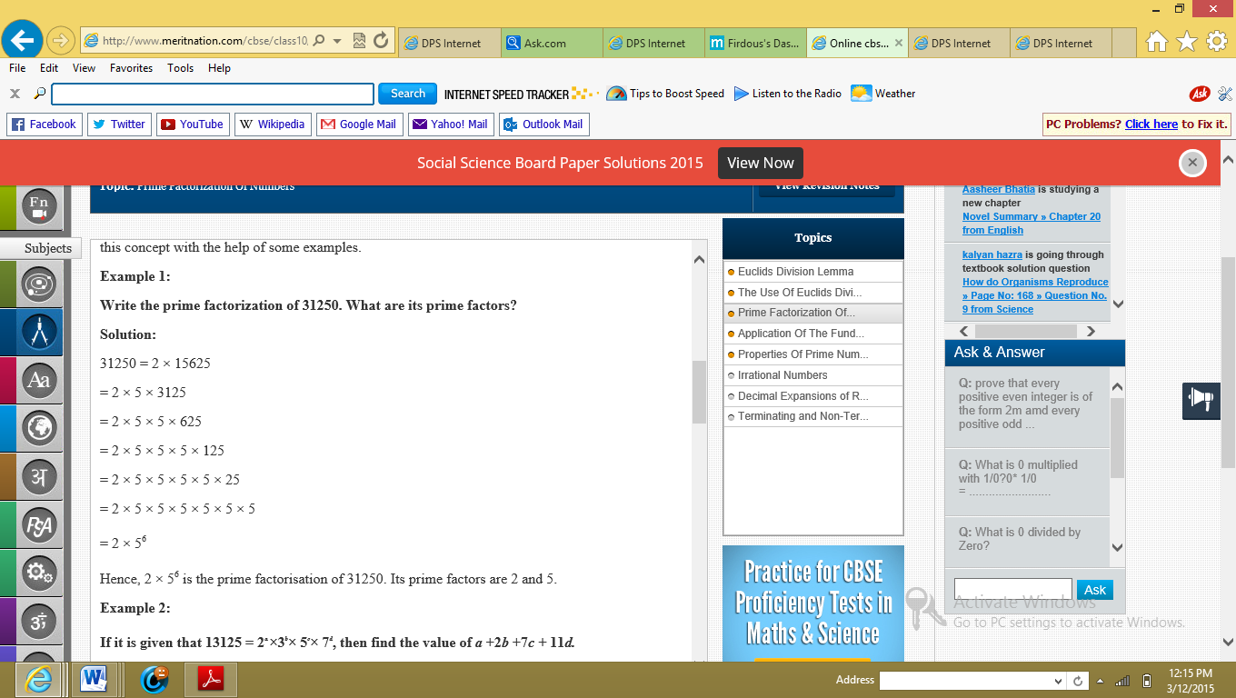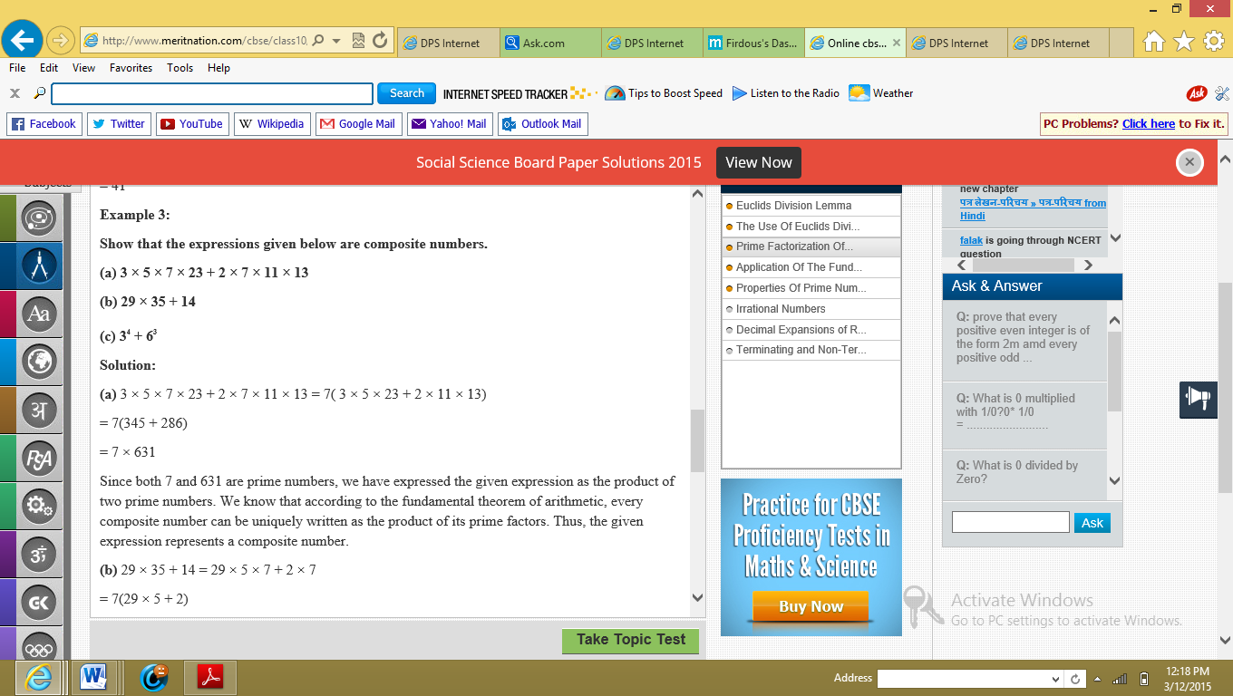

Example 2:



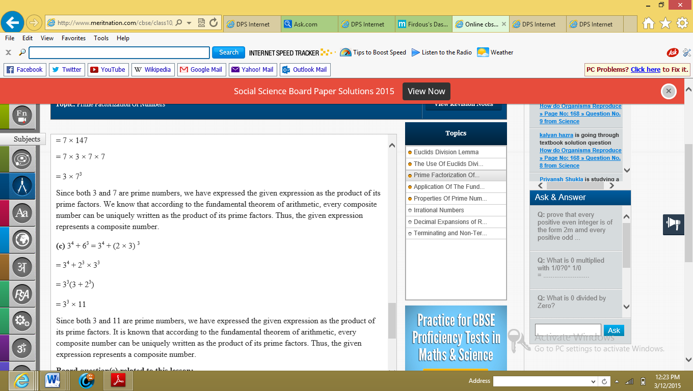

Example:

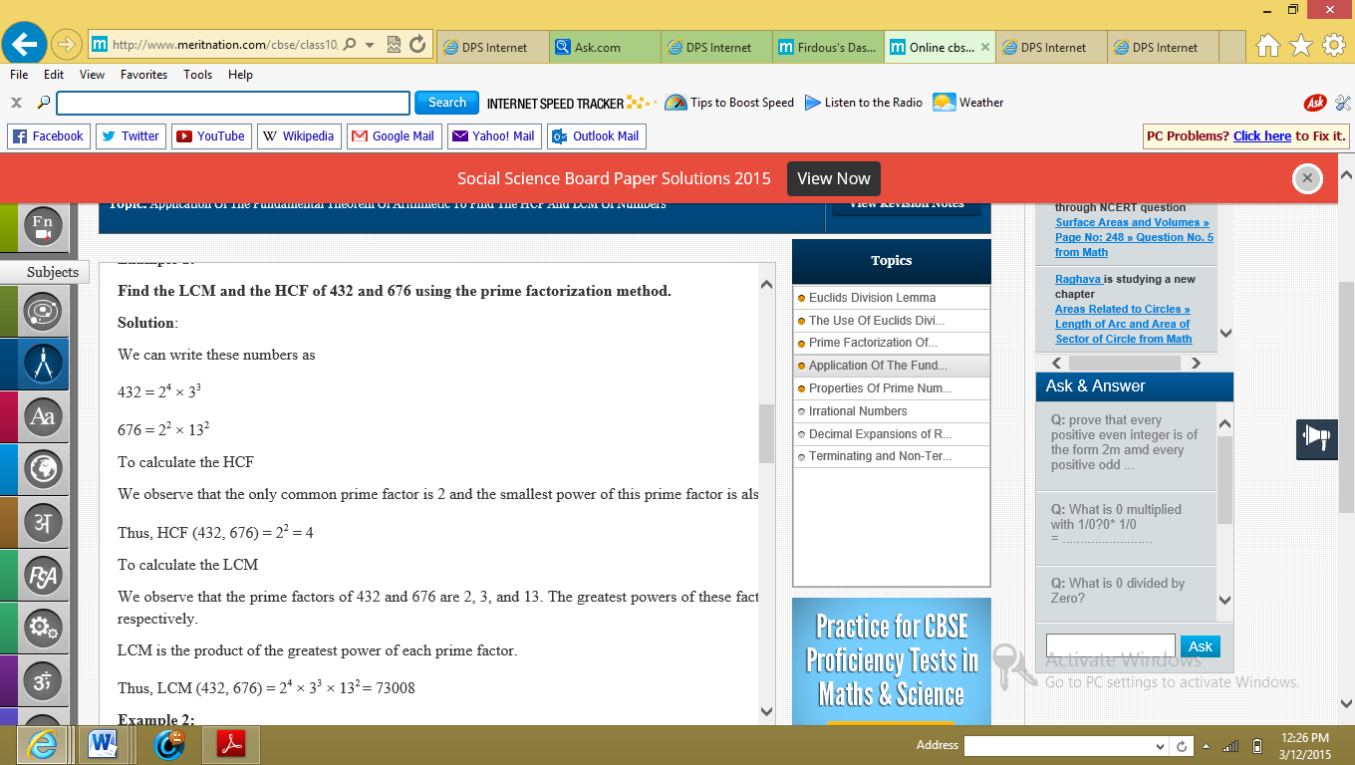

**Example:**

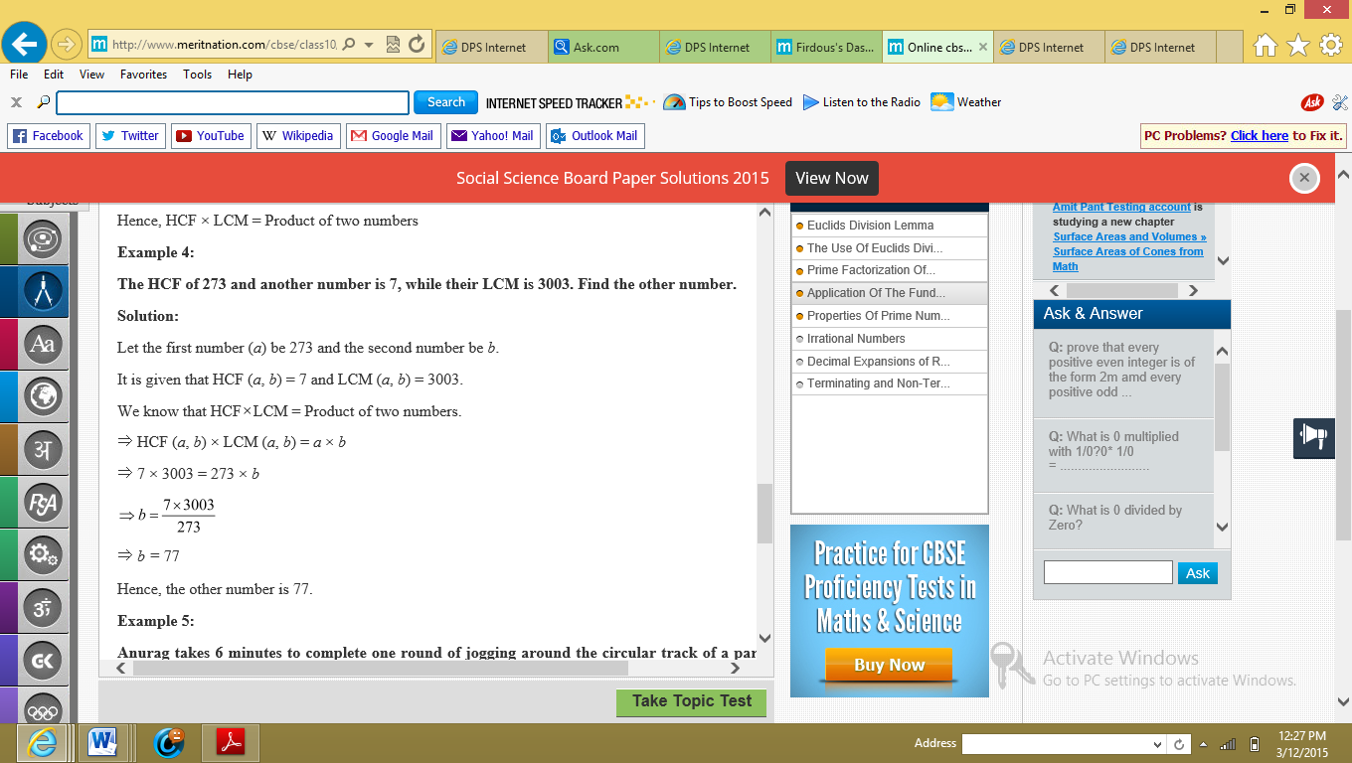

Example:

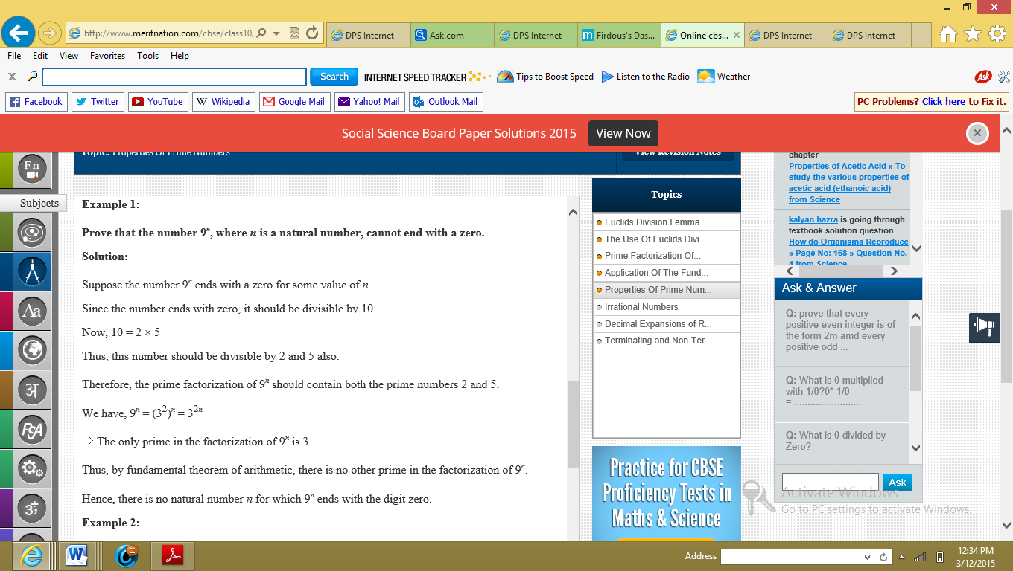

**Decimal expansion of rational numbers:**

**Theorem:**  
Let p be a prime number. If p divides a2, then p divides a, where a is a positive integer.  
  
**Theorem:**If p q is a rational number, such that the prime factorisation of q is of the form 2a5b, where a and b are positive integers, then the decimal expansion of the rational number p q terminates.  
  
**Theorem:** If a rational number is a terminating decimal, it can be written in the form p q , where p and q are co prime and the prime factorisation of q is of the form 2a5b, where a and b are positive integers.  
  
**Theorem:** If p q is a rational number such that the prime factorisation of q is not of the form 2a5b where a and b are positive integers, then the decimal expansion of the rational number p q does not terminate and is recurring.

**Note:** The product of the given numbers is equal to the product of their HCF and LCM. This result is true for all positive integers and is often used to find the HCF of two given numbers if their LCM is given and vice versa.

Example:

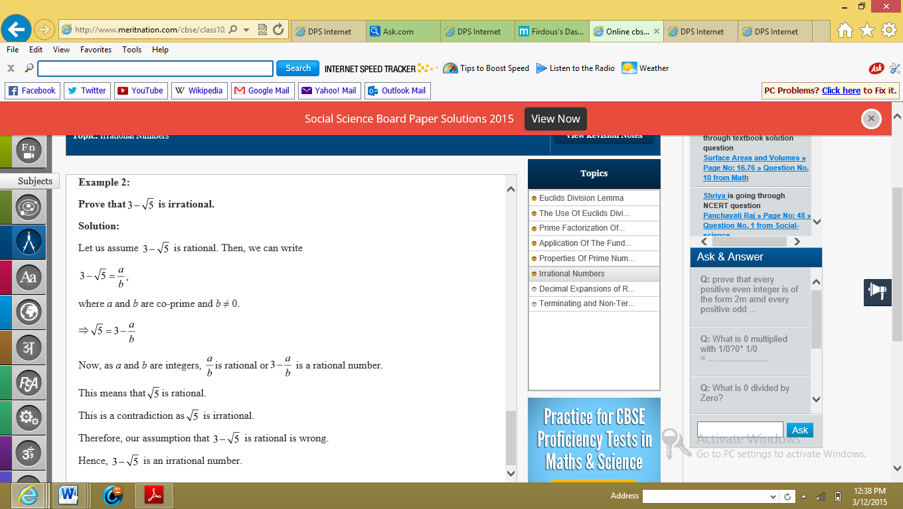

Example:

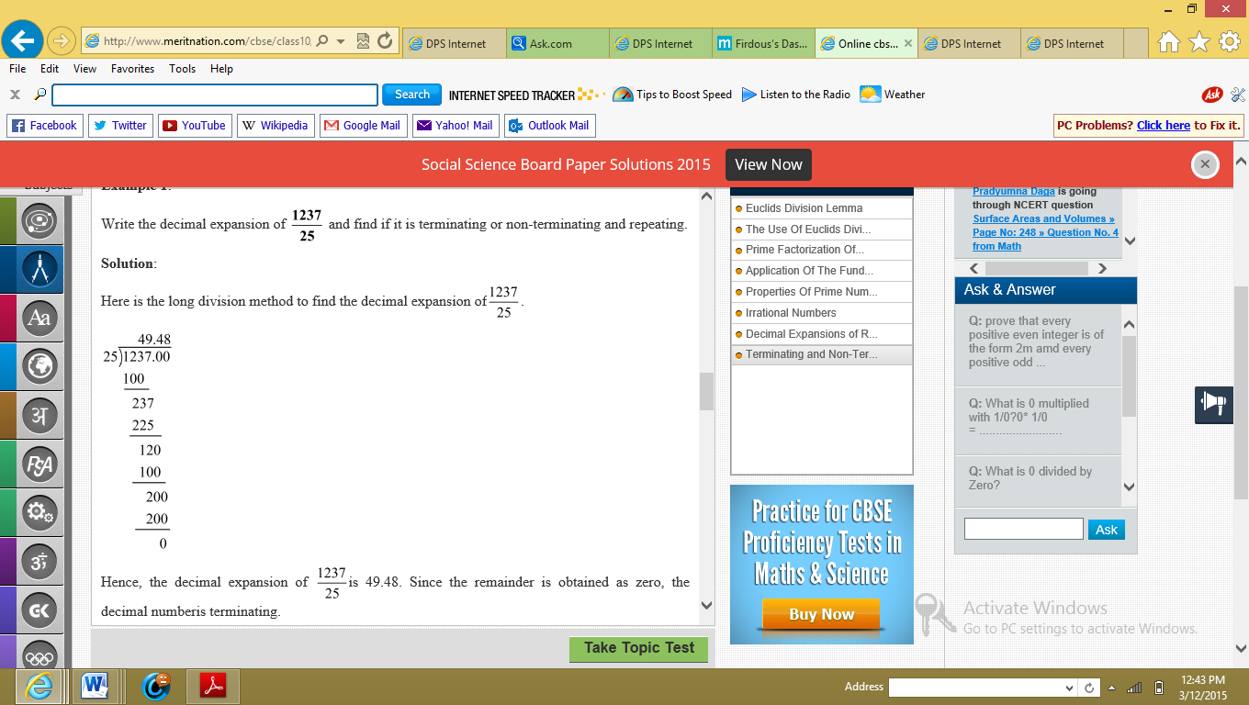

Example:

